**SCHOOL MANAGEMENT SYSTEM**

**PROJECT SUPERVISOR:**

**DR. Muhammad Ibrahem**

UNDERTAKEN BY:

Abdul Rehman

Roll No#95(E)B

BSCS

SESSION 2020- 2022

DEPARTMENT OF COMPUTER SCIENCE

Islamia UNIVERSITY OF Bahawalpur



***All Praised Are For***

***The most beneficent, who guides us in the darkness and helps in difficulties,***

***Without this help one can never achieve destination.***

***All Respects Are For His***

***HOLLY PROPHET HAZRAT MUHAMMAD (P.B.U.H)***

***Who enlighten out the minds to recognize our creature.***

**FINAL APPROVEL**

**It is to certify, that we have gone through this project report that is submitted by Nida Ali, Roll # 04, Session 2013-2017. Our judgment is that this Project is up to the standard to warrant its acceptance by the University Of South Asia Lahore for the Degree of BSCS.**

**External examiner:**

**Supervisor:**

M. Sufyan

Lecturer

Heritage International Collage Chishtian

**Chairman:**

# Dedication:

# This project is dedicated to The Planner, The Creator of the entire Universe; The Merciful ALLAH, and his loving messenger Hazarat Muhammad (Peace Be Upon Him). ALLAH has given me the power to perform this task and facilitating every possible means to complete this project.

# PROJECT BRIEF

**PROJECT NAME** School Management System

**OBJECTIVE** The main objective of this project is to provide the facility to the user to get the information about the latest School News ,Admission Criteria and also provide the facility to manage the school Database.

**Project Started _ 1st july,2017_ _ _ _ _**

**Project Finished _ 10 dec,2017 _ _ _ _ _**

**Source Language Php, Java script,jquery,Ajex,**

**TOOL MYSQL, Adobe Dreamweaver CS6, Adobe Photoshop, Xampp**

**Operating System Windows 8.1 , Windows 7 , Windows 10**

# ACKNOWLEDGMENT

Up and above everything, we are grateful almighty **ALLAH,**

The beneficent, the merciful, and his Holy Prophet Hazarat **MUHAMMAD** (peace be upon him) who is forever true light of guidance for whole humanity. We are greatly obliged “**ALLAH**” by whom grace we have been able to complete this project successfully.

We feel much obliged to our families, whom prayers and good wishes have enabled us to reached at this stage.

Our success is the result of the Technical Guidance, invaluable comments and moral support of our supervisor **Muhammad Sufyan** whose efforts and for the students are not only for projects but also throughout the session. We are very thankful to him for taking such a pain for us. We extend our thanks to all our teachers from whom we have learnt a lot during the session and their nice behavior and attitude is always encouraging us for learning.

Nida Ali.

# *ABSTRACT*

School Management System is a web base program. It provides the facility to the user to get information about Latest Admission & News by just a single click. User need to connect to a network on their home P.C.This system will help the user in about to get Information about the school at home. This system is helpful in saving the time of the user. The user did not need to go in School. This system is also helpful in exploring the use of internet. Which is one of the basic need of today.

The administrator can do all the changes of the website, and can be seen by the administrator. The platform for the system implementation is windows 8,8.1,10.Mysql is used for the backend database and phpmyAdmin is used to build the mysql queries. User interface programming is done by php scripting languages. Front end is developed by Adobe Dreamweaver. For UML diagram we used “Smart Draw 6”.

In this project there are several modules such as Data Entry module, Data Records module. These modules are further divided in to sub modules. That is Class Setup, Student Setup, Teacher Setup, Fees Setup, Student Attendance, Employee Attendance, Subject Setup, Add Expense, Expense Detail, These modules give way in managing the organization efficiently. So, this project helps in efficient management of human resource inside the organization. Also, it consumes less time consumption.

Also in all the modules the regularly updated information are very much useful when they are extracted.

**TABLE OF CONTENTS**

**Chapter 1 : Introduction**

**Chapter 2 : Feasibility Study**

**Chapter 3 : Requirement Analysis**

**Chapter 4 : Object Oriented Analysis & Design**

**Chapter 5 : System Design**

**Chapter 6 : Sitemap**

**Chapter 7: ScreenShot**

**Chapter 8: Tool Use**

**Chapter: 01**

**INTRODUCTION**

**1.1) what is Online System?**

Before knowing about the proposed system it is must to know about the Online System. The Online System is the application of science and technology to make the world move on its finger by providing the users every facility which they want while sitting at home. This system is based on web programming. Human beings have attempted to purchase the products informally for millennia, and formally since the nineteenth century. Online System are made by collecting quantitative data about the current state of the products and using automatic understanding between the user and the system .

**1.2) Introducing School Management System:**

Here we are introducing the proposed system which is a software developed to get the information about the School and News of the new admission. The main focus of project is to send automatic response to the current requests of the user .

Candidates are required to visit the admission website of the institutes .All eligibility criteria, no of seats, Selection criteria etc are mentioned on the website. If there existed, they were either at national level, or either at large scale level. Even after getting such system at local level, the user would get the School Schedule and information about school staff that were to be stored on internet, making it for the user to be online to get the information.

This system will help the user to get the information about the School System and get information about its history, scope and provide the facility to the student of the school.

**1.3) Project Scope:**

The scope of this School Management System consists of:

* The software is developed for every person who has specially want to get information

about the school and want to know its schedule and its staff.

* A web server that provides interaction with the system to the users.
* School Management System with automatic response is aCS6,XAMPP,SQL Server that allows the user to get the information about the School architecture and comparison it to other school directly over his home P.C.
* User can see the fee information directly over his home P.C.
* A database is required**.**
* Admin will have an authentication.
* The system will be accessible to all who have Internet facilities.

**1.4) Objective of the system:**

* To authenticate the administrator so that only the registered administrator can make the changes manage the whole site.
* Maintain database of Administrator .
* Provide an interface to Admin to interact easily.
* Give the Admin data security so that not other person watch the Admin data.

**1.5) Tools & Technologies:**

This system is developed by using

* PHP,
* JAVA Script,
* J Query,
* Ajex,
* MYSQL Server,
* MICROSOFT Office 2010,
* DREAMWEAVER CS6 2008,
* XAMPP,
* HTML,
* Cascading style sheets,
* Adobe Photoshop,
* Windows 10.

**Chapter: 02**

**Feasibility Study**

**Feasibility Study:**

A feasibility study is a preliminary study undertaken to determine and document a

Project’s viability. The results of this study are used to make a decision whether to

Proceed with the project, or not.

A feasibility study could be used to test a new working system, which could be used

because:

* The current system may no longer suit its purpose,
* Technological advancement may have rendered the current system redundant,
* The business is expanding, allowing it to cope with extra work load,
* Customers are complaining about the speed and quality of work the business providers,
* Competitors are now winrling a big enough market share due to an effective integrations of a computerized system.

These Areas which must be reviewed when starting the feasibility study.

1. Technical
2. Operation
3. Economics
4. Schedule
5. Speciﬁcation
6. Information
7. Motivational

**1) Technical Feasibility:**

The system which is to be developed is web based, and PHP technology along with

MySql will be used to develop it. The project team has got the status to use these

technologies. The software required for doing this project is easily available.

**2)** **Operational Feasibility:**

The staff that will be designed software so that it is easy to use. They will additionally

Provided with help and guidance (if needed) to operate the software.

**3) Economic Feasibility:**

There is no need for purchasing the tools and license used during the development of the project. All tool and technologies that are required during development are already with the development team. This makes the development economically feasible. Only costing factor is the effort of the project members and time that is utilized in project development. The maintenance cost and operation cost is there.

**4) Schedule Feasibility:**

Time is an important factor. We have got the required team and resources to complete if the project on time. We all are in the final semester of our program and there is sufficient time available to us for completing this project on the required date and time.

**5) Specification Feasibility:**

The project team has a clear picture of what we have to develop and what the system must have in it to be successful. The project team will have a complete and clearer picture when we are through with the requirements speciﬁcation and gathering phase. The requirements are becoming clearer and deﬁnite with the passage of time.

**6)** **Information Feasibility:**

The information regarding its completion, reliability, and rneaningfulness is ensured

by the use of the Internet, books, and software development requirements. The project

will itself be informative and helpful to the concerned authorities after completion.

**7) Motivational Feasibility:**

The client’s staff that will actually using the system are motivated to use this system as one of the goals of the system is helping them with their work.

**8) Legal & Ethical Feasibility:**

The system is free of any infringements or liabilities. It is not violating any legal or ethical values.

**Chapter: 03**

**Requirement Analysis**

**Tools Required:**

* Apache Web server Version
* PHP Script Language Version 5.1.1
* MYSQL Database Manager Version 2.6.4—pl4
* Adobe Dreamweaver Version CS 5
* Mozilla Firefox

**3.1 Details About Tools:**

**INTRODUCTION or PHP:**

PHP, which stands for "PHP: Hypertext Preprocessor" is a widely-used Open Source general-purpose scripting language that is especially suited for Web development and can

be embedded into HTML PHP has come a long way in the last few years. Growing to be one of the most prominent languages powering the Web was not an easy task PHP is a widely-used general-purpose scripting language that is especially suited for Web development. Its syntax draws upon C, Java, and Perl, and is easy to learn. The main goal

of the language is to allow web developers to write dynamically generated web pages quickly.

PHP is a cross-platform, HTML-embedded, server-side web scripting language Let's take a moment to deﬁne these terms:

**Cross-Platform:**

You can run most PHP code, without alteration, on computers running many different 5

operating systems. A PHP script that runs on Linux will generally run on Windows as

well.

**HTML-Embedded:**

PHP code is written in ﬁles containing a mixture of PHP instructions and HTML code.

**Server-Side:**

The PHP programs we write are run on a server — speciﬁcally, a web server.

**A Web scripting Language:**

We run PHP programs via a web browser. We access the web server on which they reside, and this runs the program, sending any resulting output back to the browser. This is different from a script written in other languages like Perl or C++ instead of a writing a program with lots of commands to output HTML, you write an HTML script with some embedded code to do something (in this case, output some text). The PHP code is enclosed in special start and end tags that allow you to jump into and out of "PHP mode".

**PHP 4:**

By the winter of l998, shortly after PHP 3.0 was officially released, Andi Gutmans and

Zeev Suraski had begun working on a rewrite of PHP's core. The design goals were to

Improve performance of complex applications, and improve the modularity of PHP's

code base. Such applications were made possible by PHP 305 new features and support

for a wide variety of third party databases and APIS, but PHP 3.0 was not designed to

handle such complex applications efficiently.

The new engine, dubbed 'Zend Engine’(comprised of their first names, Zeev and Andi),

met these design goals successfully, and was first introduced in mid 1999. PHP 4.0, based

on this engine, and coupled with a wide range of additional new features, was officially

released in May 2000, almost two years after its predecessor, PHP 3.0. In addition to the

highly improved performance of this version, PHP 4.0 included other key features such as support for many more Web servers, HTTP sessions, output buffering, more secure ways of handling user input and several new language constructs.

PHP 4 is currently the latest released version of PHP. Work has already begun on

modifying and improving the Zend Engine to integrate the features which were designed

for PHP 5.0.

Today, PHP is being used by hundreds of thousands of developers (estimated), and

several million sites report as having it installed, which accounts for over 20% of the domains on the Internet.

**PHP 5:**

The future of PHP is mainly driven by its core, the Zend Engine. PHP 5 will include the

new Zend Engine 2.0. To get more information on this engine

**PEAR :**

PEAR, the PEP Extension and Application Repository (originally, PHP Extension and

ﬁdd-on Repository) 1S PHP's version of foundation classes, and may grow in the future to be one of the key ways to distribute both PHP and C-based PHP extensions among .

developers.

**3.2 What can PHP do?**

PHP is mainly focused on server-side scripting. so you can do anything any other CGI

program can do, such as collect form data, generate dynamic page content. or send and

receive cookies. But PHP can do much more. There are three main ﬁelds where PHP

scripts are used.

* **Server-side scripting.** This is the most traditional and main target ﬁeld for PHP. You need three things to make this work. The PHP parser (CGI or server module), a web server and a web browser. You need to run the web server, with a connected PHP installation. You can access the PHP program output with a web if browser, viewing the PHP page through the server.
* **Command line scripting.** You can make a PHP script to run it without any server or browser. You only need the PHP parser to use it this way. This type of usage is ideal for scripts regularly executed using cron (on *nix or Linux) or Task

Scheduler (on Windows). These scripts can also be used for simple text processing tasks.

* **Writing Client-Side GUI Applications:** PHP is probably not the very best language to write windowing applications, but if you know PHP very well, and ,would like to use some advanced PHP features in your client-side applications you can also use PHP-GTK to write such programs. You also have the ability to write cross-platform applications this way. PHP-GTK is an extension to PHP, not available in the main distribution.

PHP can be used on all major operating systems, including Linux, many UNIX variants,

Microsoﬁ Windows, Mac OS, and probably others. PHP has also support for most of the

web servers today. This includes Apache, Microsoft internet Information Server, Personal Web Server, Netscape and iPlanet servers for the majority of the servers PHP 2 has a module, for the others supporting the CGI standard, PHP can work as a CGI processor.

So with PHP, you have the freedom of choosing an operating system and a web server.

Furthermore, you also have the choice of using procedural programming or object oriented programming, or a mixture of them. Although not every standard OOP feature is

realized in the current version of PHP, many code libraries and large applications

(including the PEAR library) are written only using OOP code.

With PHP you are not limited to output HTML. PHP's abilities include outputting images, PDF ﬁles and even Flash movies (using libswf and Ming) generated on the fly. You can also output easily any text, such as XHTML and any other XML ﬁle. PHP can

auto generate these ﬁles, and save them in the ﬁle system, instead of printing it out forming a server-side cache for your dynamic content.

**Support for a wide range of database:**

One of the strongest and most signiﬁcant features in PHP is its support for a wide range

of databases. Writing a database-enabled web page is incredibly simple. The following

databases are currently supported:

Adabas D Ingres Oracle (OCI7 and OCI8)

dBase InterBase Ovrimos

Empress FrontBase PostgreSQL

FilePro (read-only) mSQL Solid

Hyperwave Direct MS—SQL Sybase

IBM DB2 MySQL Velocis

Infonnix ODBC Unix dbm

Additionally PHP supports ODBC, the Open Database Connection standard, so you can

connect to any other database supporting this world standard.

PHP also has support for talking to other services using protocols such as LDAP, IMAP, SNMP, NNTP, POP3, HTTP, COM (on Windows) and countless others. You can also open raw network sockets and interact using any other protocol. PHP has support for the

WDDX complex data exchange between virtually all Web programming languages.

Talking about interconnection, PHP has support for instantiation of Java objects and using them transparently as PHP objects.

While using PHP in the e—commerce ﬁeld, you'll find the Cybercash payment, CyberMUT, VeriSign Payflow Pro and CCVS functions useful for your online payment programs.

**3.3 PHP and other languages:**

PHP is the best language for web programming, but what about other languages?

**1. PHP vs. ASP?**

**2. Is there an ASP to PHP converter?**

**3. PHP vs. Cold Fusion?**

**4. PHP vs. Perl?**

**3.3.1 PHP vs. ASP?**

ASP is not really a language in itself, it's an acronym for Active Server Pages and the

actual language used to program ASP with is Visual Basic Script or J—Script. The

drawback of ASP is that it's a proprietary system that is natively used only on Microsoft

Internet Information Server (IIS). This limits it's availability to Win32 based servers.

There are a couple of projects in the works that allows ASP to run in other environments

and web servers. ASP is said to be a slower and more cumbersome language than. PHP,

less stable as well. Some of the pros of ASP is that since it primarily uses VBScript it’s

relatively easy to pick up the language if you're already know how to program in Visual

Basic. ASP support is also enabled by default in the IIS server making it easy to get up

and running. The components built in ASP are really limited, so if you need to use

"advanced" features like interacting with FTP servers, you need to buy additional

components.

**Is there an ASP to PHP converter?**

Yes, the server-side asp2php is the one most often referred to as well as this client-side

option.

**3.3.2 PHP vs. Cold Fusion?**

PHP is commonly said to be faster and more efficient for complex programming tasks and trying out new ideas. PHP is generally referred to as more stable and less resource

intensive as well. Cold Fusion has better error handling, database abstraction and date

parsing although database abstraction is addressed in PHP 4. Another thing that is listed

as one of Cold F usion's strengths is its excellent search engine, but it has been mentioned

that a search engine is not something that should be included in a web scripting language.

PHP runs on almost every platform there is; Cold Fusion is only available on Win32, Solaris, I.inux and HP/UX. Cold Fusion has a good IDE and is generally easier to get started with, whereas PHP initially requires more programming knowledge. Cold Fusion

is designed with non—programmers in mind, while PHP is focused on programmers.

**3.3.3 PHP vs. Perl?**

The biggest advantage of PHP over Perl is that PHP was designed for scripting for the

web where Perl was designed to do a lot more and can because of this get very complicated. The ﬂexibility / complexity of Perl makes it easier to write code that

another outher / coder has a hard time reading. PHP has a less confusing and stricter

format without losing fexibility. PHP is easier to integrate into existing HTML than Perl.

PHP has pretty much all the 'good' functionality of Perl: constructs, syntax and so on,

without making it as complicated as Perl can be. Perl is a very tried and true language, it's

been around since the late eighties, but PHP is maturing very quickly.

**3.4 MySql :**

**3.4.1 Introduction**

A relational database management system (RDBMS) is an essential tool in many environments, from the more traditional uses in business, research, and education

contexts, to newer applications, such as powering search engines on the Internet.

Historically, database systems have been an expensive proposition, with vendors

charging healthy fees both for software and for support. In addition, because database

engines often had substantial hardware requirements to run with any reasonable

performance, the cost was even greater.

The no-to-low cost database arena is MySQL, a SQL (Structured Query Language)

client/server relational database management system originating from Scandinavia.

MySQL includes a SQL server, client programs for accessing the server, administrative

tools, and a programming interface for writing your own programs.

MySQL's roots began in 1979, with the UNIREG database tool created by Michael

"Monty" Widenius for the Swedish company TeX. In 1994, TeX began looking around

for a SQL server for use in developing Web applications. They tested some commercial

servers, but found all too slow for TcX's large tables. They also took a look at MySQL,

but it lacked certain features TeX required. Consequently, Monty began developing a

new server. The programming interface was designed explicitly to be similar to the one

used by MySQL because several free tools were available for MySQL; by using a similar

interface, those same tools could be used for MySQL with a minimum of porting effort.

MySQL continues to develop. The addition of features such as transactions, row-level locking, foreign key support, and replication has caused people who once would have considered only "big engine" databases for their applications to give MySQL a second

look.

MySQL is an Open Source project that can be used for free under most circumstances,

for which reason it enjoys widespread popularity in the Open Source community. But

MySQL's popularity isn't limited to Open Source enthusiasts. Yes, it runs on personal

computers (indeed, much MySQL development takes place on inexpensive Linux

systems). But MySQL is portable and runs on commercial operating systems (such as

Solaris, Mac OS X, and Windows) and on hardware all the way up to enterprise servers.

liurthermore, its performance rivals any database system you care to put up against it, and

it can handle large databases with millions of records.

**3.4.2 Why Choose MySQL?**

* **Speed:**

MySQL is fast. The developers contend that MySQL is about the fastest database you can get. You can investigate this claim by visiting http://www.mysql.com/benchmark.html, a performance-comparison page on the MySQL Web site.

* **Ease of use:**

MySQL is a high-performance but relatively simple database system and is much less complex to set up and administer than larger systems.

* **Query language support:**

MySQL understands SQL, the language of choice for all modern database systems.

* **Capability:**

Many clients can connect to the server at the same time. Clients can use multiple databases simultaneously. You can access MySQL interactively using several interfaces that let you enter queries and view the results: command-line clients, Web browsers, or X Window System clients. In addition, a Variety of programming interfaces are available for languages such as C, Perl, Java, PHP, and Python. You can also access MySQL using applications that support ODBC (Open Database Connectivity), a database communications protocol developed byMicrosoft. Thus, you have the choice of using prepackaged client software or writing your own for custom applications.

* **Connectivity and security:**

MySQL is fully networked, and databases can be accessed from anywhere on the Internet, so you can share your data with anyone, anywhere. But MySQL has access control so that people who shouldn't see your data can't. To provide additional security, MySQL now supports encrypted connections using the Secure Sockets Layer (SSL) protocol.

* **Portability:**

MySQL runs on many varieties of UNIX, as well as on other non-UNIX systems, such as Windows and OS/2. MySQL runs on hardware from home PCs to high-

end servers.

* **Small size:**

MySQL has a modest distribution size, especially compared to the huge disk space footprint of certain commercial database systems.

* **Availability and cost:**

MySQL is an Open Source project, freely available under the terms of the GNUGeneral Public License (GPL). This means that MySQL is free for most in-house uses. (If you want to sell MySQL or- services that require it, that IS a different situation and you should contact MySQL AB.)

* **Open distribution:**

MySQL is easy to obtain; just use your Web browser. If you don't understand how something works or are curious about an algorithm, you can get the source code and poke around in it. If you don't like how something works, you can change it.

The MySQL community, developers and non-developers alike, is very responsive.

Answers to questions on the mailing list often arrive within minutes. When bugs are

reported, the developers generally release a fix quickly, and ﬁxes become available

immediately over the Internet.

**3.4.3 Tools Provided with MySQL:**

The MySQL distribution includes the following tools:

* **A SQL server:**

This is the engine that powers MySQL and provides access to your databases.

* **Client programs for accessing the server:**

An interactive program allows you to enter queries directly and view the results, and several administrative and utility programs help you run your site. One utility allows you to control the server. Others let you import or export data, check access permissions, and more.

* **A client library for writing your own programs:**

You can write clients in because the library is in C, but the library also provides the basis for third-party bindings for other languages.

**3.5 Apache Server :**

**3.5.1 Introduction :**

Often reffered to as simply Apache,a public-domain open source Web server developed

by a loosely-knit group of programmers.The first version of Apache, based on the NCSA

http Web server,was developed in 1995.

Core development of the Apache Web server is performed by a group of about 20

volunteer programmers, called the Apache Group.However, because the source code is

freely available,anyone can adopt server for speciﬁc needs,and there is a large public

library of Apache add-ons.ln many respect, development of Apache is similar to

development of the Linux operating system.

The original version of Apache was written for UNIX, but there are new versions that run under OS/2, Windows and other platforms.

The name is a tribute to the Native American Apache Indian tribe,a tribe well known for its endurance and skill in warfare.A common misunderstanding is that it was called the

name a patchy server , or Apache server.

**3.5.2 What is phpMyAdmin ?**

phpMyAdmin is a tool written in PHP intended to handle the administration of MySQL

over the Intemet.Currently it can creat and drop databases,creat/drop/alter tables,

delete/edit/add ﬁelds, execute any SQL statement, and manage keys on ﬁelds.

**3.5.3 History :**

Tobias Ratschiller, then an IT consultant and later founder of the software company Maguma,started-to work on a PHP- based web frontend to MySQL in 1998, inspired by Peter Kuppelwieser’s MySQL-Webadmin. When he gave up the project in 2000 because of lack of time, phpMyAdmin had already become one of the most popular PHP application and MySQL administration tools with a large community of users and contributors.it is also included in many Linux distributions.

In order to coordinate the growing number of patches, a group of three developers,Olivier Muller, Marc Delisle and Loic Chapeaux, registered the phpMyAdmin Project at SourceForge and took over the development in 2001.

**EQUIPMENT AND PROCEDURE:**

**\*Processor:**

* 2.0 Core2 Duo

**\*RAM:**

* 4GB

**\*Hard Disk:**

* 320 GB

**\*Operating System:**

* Window7
* Window Xp
* Window 8.1

**Chapter: 04**

**Object Oriented Analysis & Design**

**4. Introduction :**

For analysis and design purpose the Uniﬁed Modeling Language (UML) is used.ls UML,

a system is represented using five different “Views” that describe the system from

distinctly diﬂerent perspective. Each view is defined by a set of diagrams.The following

three views is UML will be discussed.

* Inception
* Elaboration
* Construction
* Transition

**4.1 Inception Phase :**

This jobsite has main two fields.

1. User

2. Administration

**4.1.1 Administrator:**

For the security reason we have separated the admin interface separate,which is known to the administrator only.

1. The admin enter it’s usemame and password.

2. The script check whether that usemame and password combination do exist in

the database.

3. If it is set the session then go the admin main page.

4. If it is not then show an error message.

After the administrator login, he will reach to the admin control panel.ln the admin control panel there are some main contents to be disscused.

**4.1.2.1 Student:**

* View
* Add New
* Delete
* Update

**4.1.2.1 Student Fee:**

* View
* Add New
* Delete
* Update

**4.1.2.2 Staff:**

* View
* Add New
* Delete
* Update

**4.1.2.3 Finance:**

* View
* Add New
* Delete
* Update

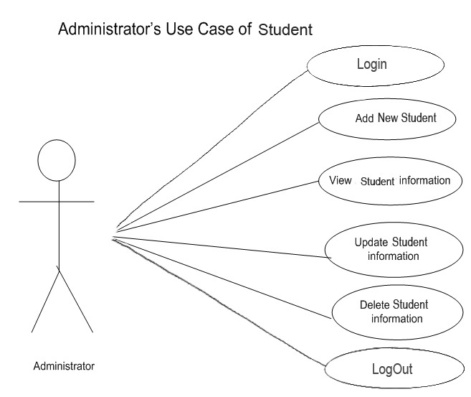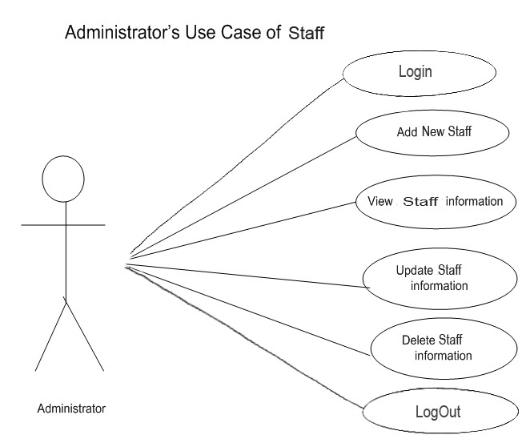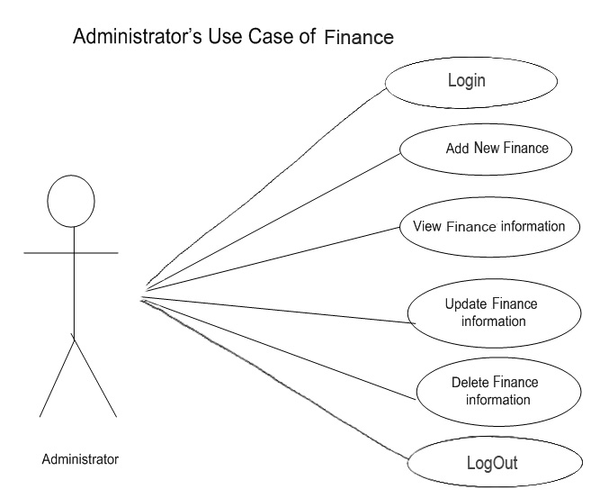

**4.2 Elaboration Phase:**

In the phase I shall identify system boundaries, by identifying actors and the use cases and i shall break the System into Sub Systems.

**4.2.1 Actors:**

There are two actors that interact with jobsite.

* **User**
* **Administrator**

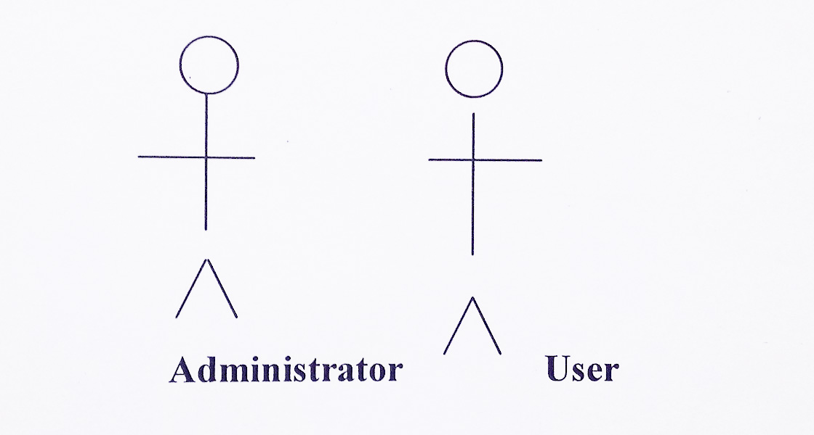

**4.2.2 Actors Description:**

**4.2.2.1 Administrator:**

He is the main controller of the web site. He can Add/Delete Categories, Users etc.

**4.2.3 Use Case Name :Administrator Login**

**Description**

This use case describe the process that how the administrator log in the system.

Through this the admin can enter into the admin control panel.

**Actors :**

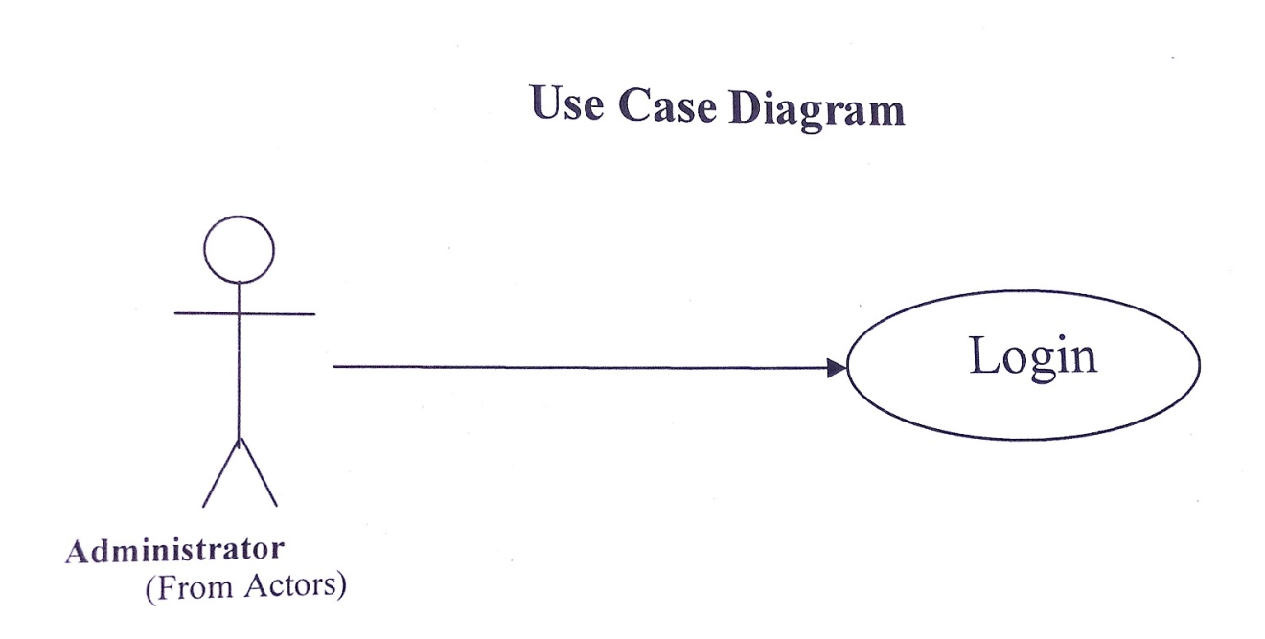

**Pre Conditions :**

The user must have the access rights to run the current system.

**Flow of Events :**

* Administrator opens the main page of the site.
* A login page appears where he enters the information.
* If information is right then access granted otherwise error message is displayed.

**Scenario Variation :**

* The database notiﬁes the user when his password or name is invalid.
* Login form will reappear for entering again name and password.
* The use case ends.

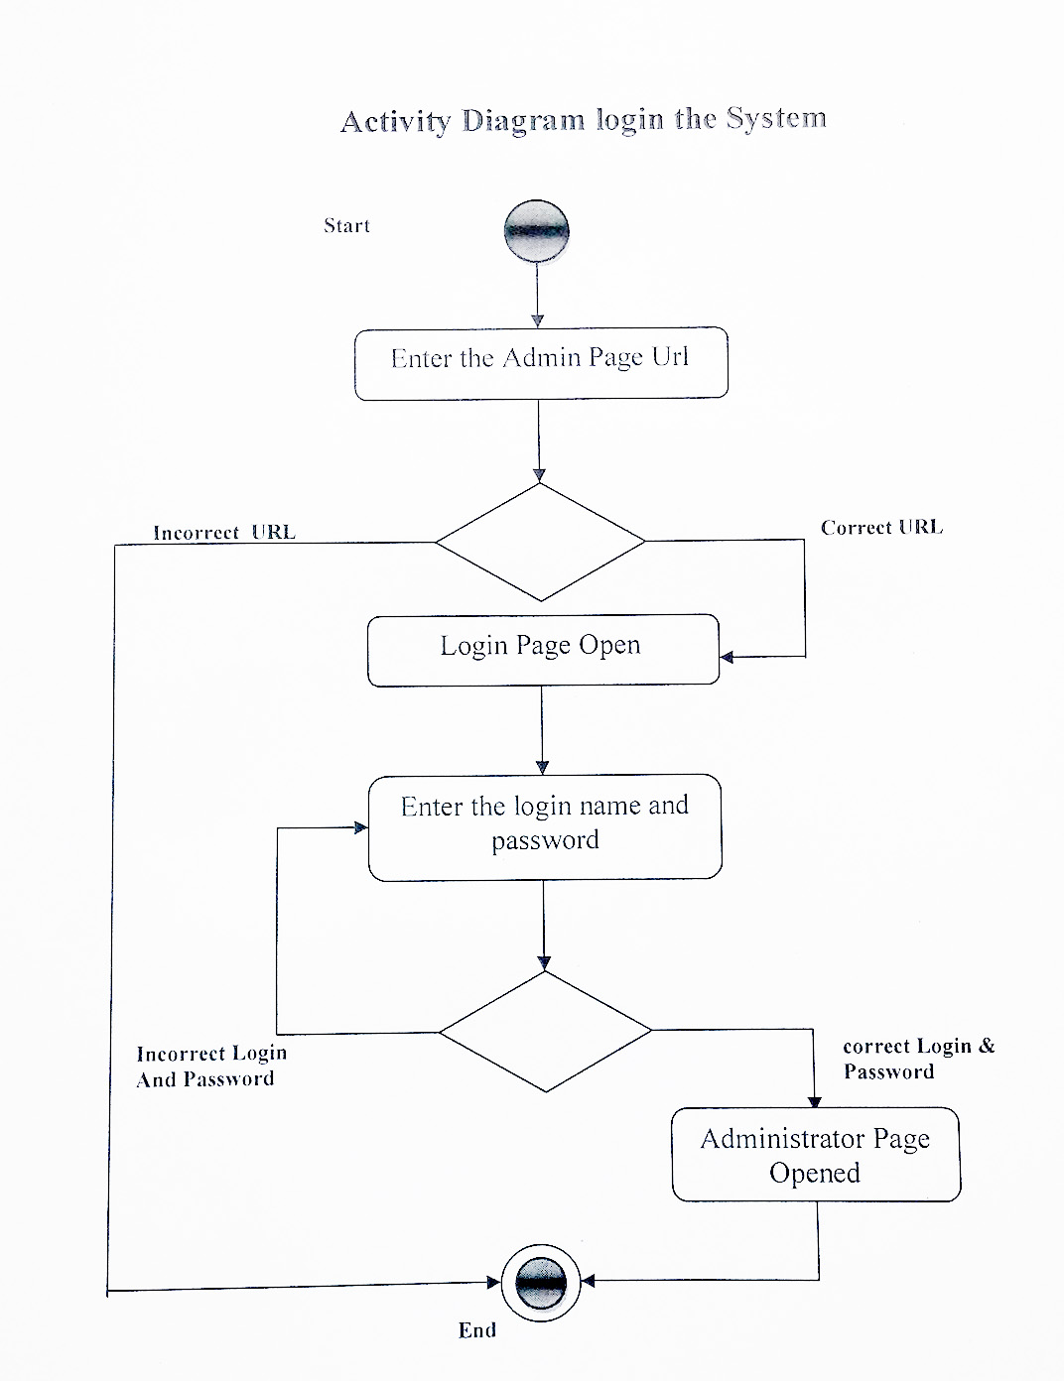

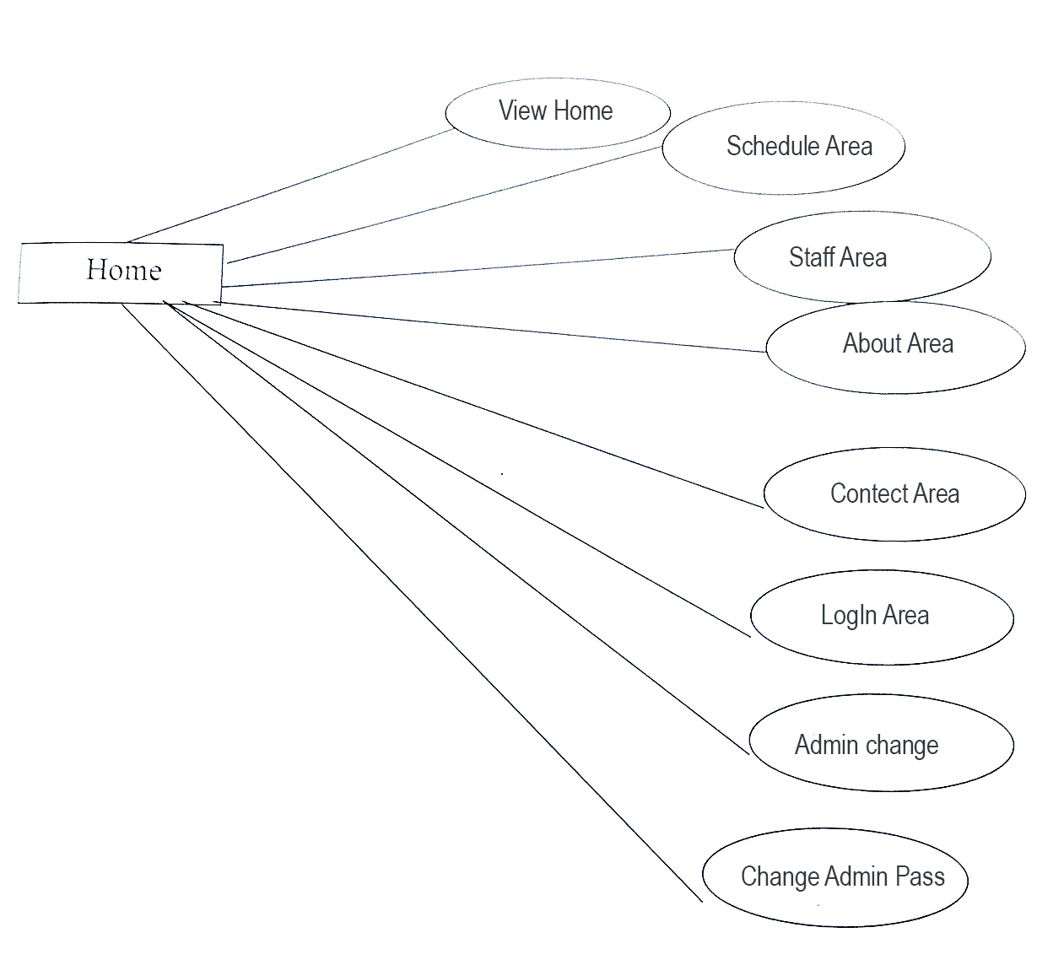

**Activity Diagram**

Login:

Submit Admin Email Password



Invalid Login

Admin Page

Verify User Email Password

Enter Admin Email Password



**Use Case of Add New Student :**

|  |  |
| --- | --- |
| Use Case ID | USECASE School Management system_1 |

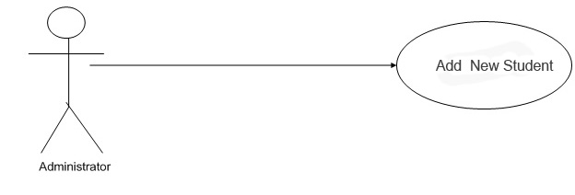

|  |  |
| --- | --- |
| Use Case Title | Add New Student |
| Actors | Administrator |
| Pre-condition | Administrator must be entered into his account and has click on New. |
| Trigger | Click on Student. |
| Post-condition | Added successfully. |
| Main flow sequence | 1. Enter category. 2. Select status(Active or logout)s |
| Alternative flow | If no data is entered in the category field then error message will appear. |

**Activity Diagram of Add New Student**

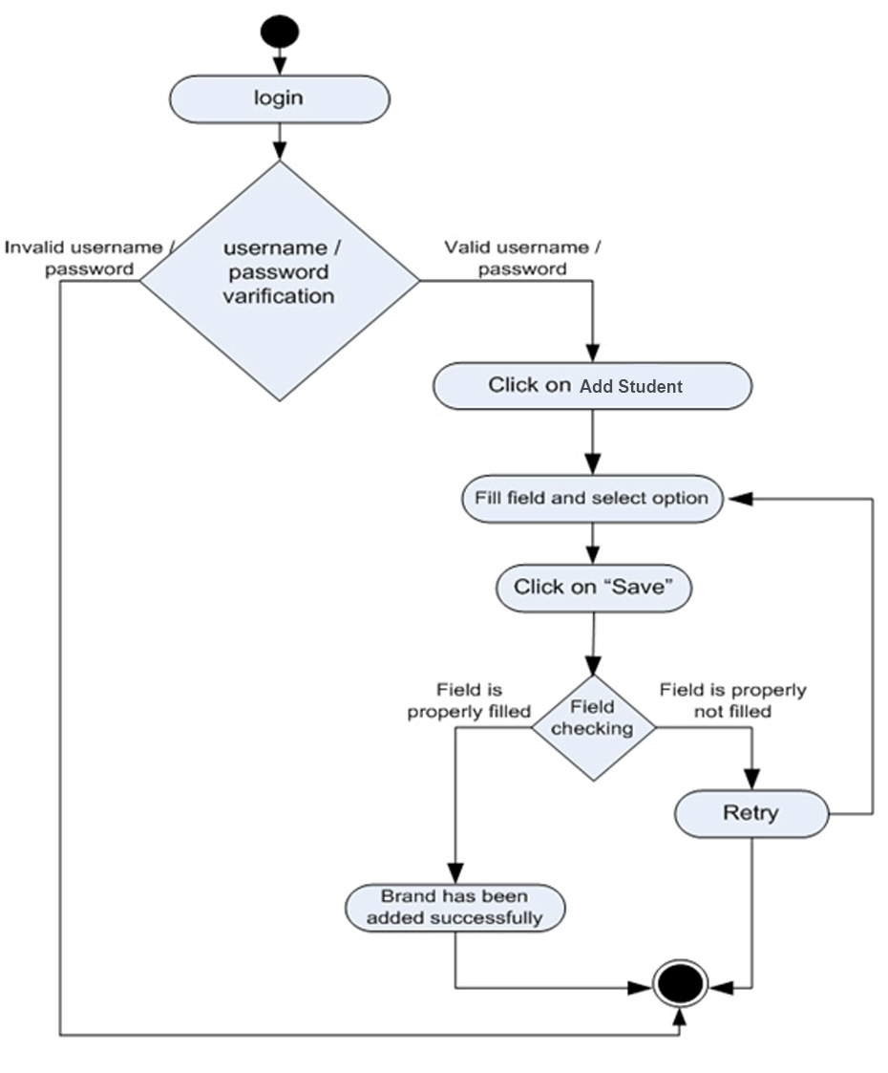

**Use Case of View Student :**

|  |  |
| --- | --- |
| Use Case ID | USECASE School Management system_2 |

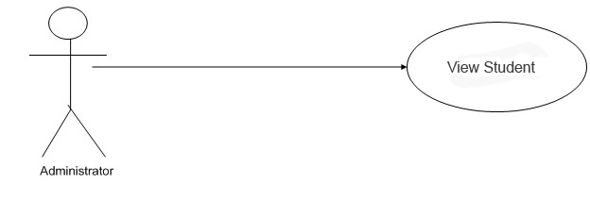

|  |  |
| --- | --- |
| Use Case Title | View Student |
| Actors | Administrator |
| Pre-condition | Administrator must be entered into his account and has click on View Student. |
| Trigger | Click on View. |
| Post-condition | View all Student . |

**Activity Diagram of View Student :**

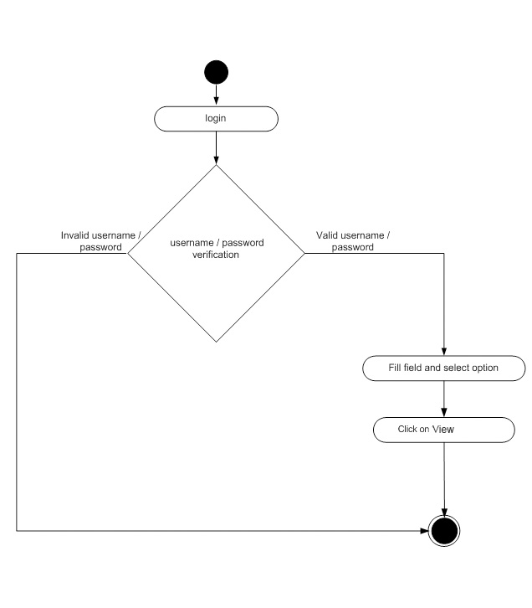

**Use Case of Update Student:**

|  |  |
| --- | --- |
| Use Case ID | USECASE_ School Management system _3 |

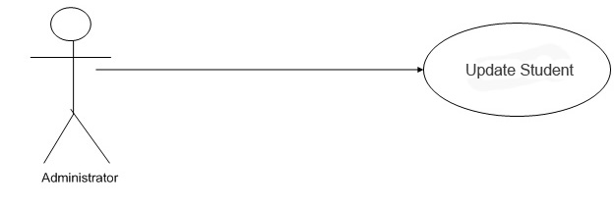

|  |  |
| --- | --- |
| Use Case Title | Update Student . |
| Actors | Administrator |
| Pre-condition | Administrator must be entered into his account and has click on Update Student. |
| Trigger | Click on Update . |
| Post-condition | Updated successfully. |

**Activity Diagram of Update Student:**

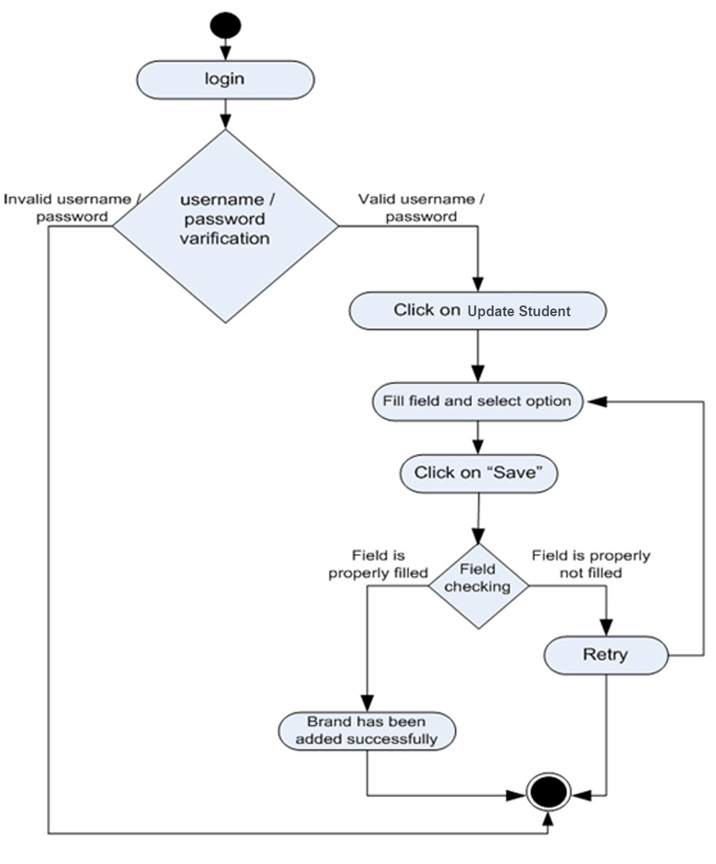

**Use Case of Delete Student:**

|  |  |
| --- | --- |
| Use Case ID | USECASE_ School Management system _4 |

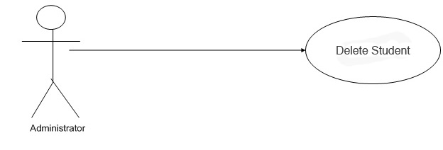

|  |  |
| --- | --- |
| Use Case Title | Delete Student |
| Actors | Administrator |
| Pre-condition | Administrator must be entered into his account and has click on Student. |
| Trigger | Click on Delete . |
| Post-condition | Deleted successfully. |

**Activity Diagram of Delete Student**

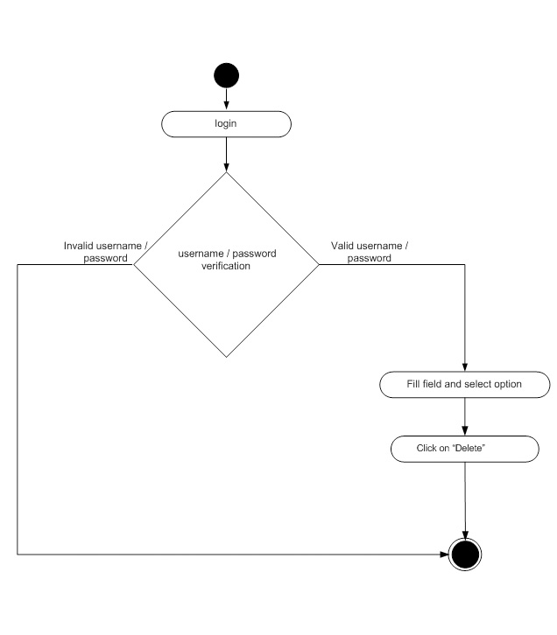

**Use Case of Add New Staff:**

|  |  |
| --- | --- |
| Use Case ID | USECASE_ School Management system _5 |

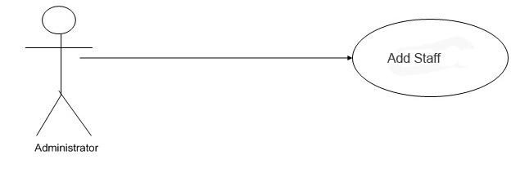

|  |  |
| --- | --- |
| Use Case Title | Add New Staff |
| Actors | Administrator |
| Pre-condition | Administrator must be entered into his account and has click on Add New Staff. |
| Trigger | Click on Add Staff. |
| Post-condition | Added successfully. |
| Main flow sequence | 1. Designer category. 2. Designer name. |
| Alternative flow | If no data is entered in the Designer field then error message will appear. |

**Activity Diagram of Add New Staff**

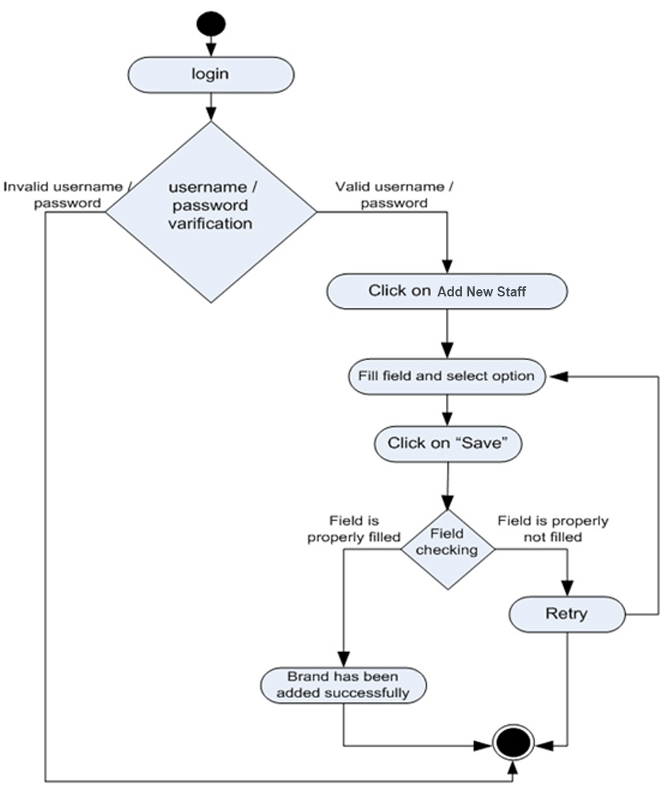

**Use Case of View Staff:**

|  |  |
| --- | --- |
| Use Case ID | USECASE_ School Management system _6 |

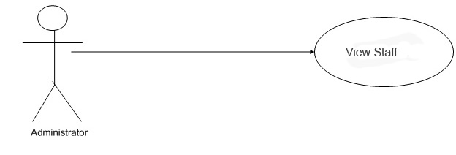

|  |  |
| --- | --- |
| Use Case Title | View Staff |
| Actors | Administrator |
| Pre-condition | Administrator must be entered into his account and has click on View Staff. |
| Trigger | Click on View. |
| Post-condition | View all Staff. |

**Activity Diagram of View Staff:**



**3.2.7)Use Case of Update Staff:**

|  |  |
| --- | --- |
| Use Case ID | USECASE_ School Management system _7 |

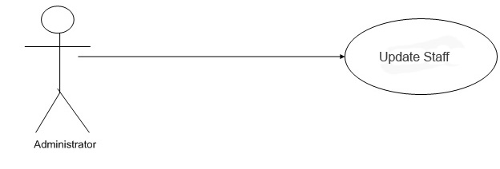

|  |  |
| --- | --- |
| Use Case Title | Update Staff |
| Actors | Administrator |
| Pre-condition | Administrator must be entered into his account and has click on Update . |
| Trigger | Click on Update. |
| Post-condition | Update successfully. |

**Activity Diagram of Update Staff:**

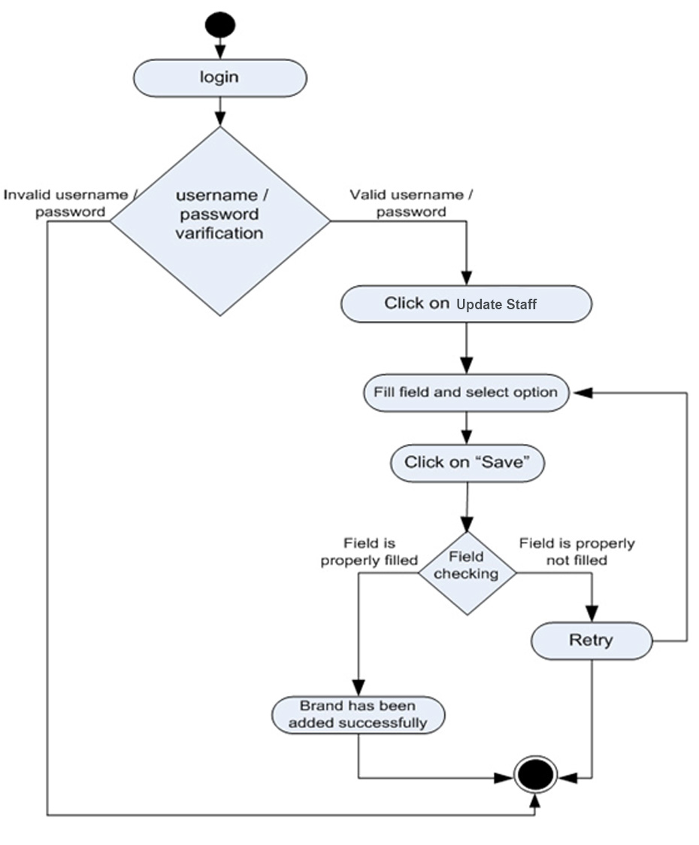

**Use Case of Delete Staff:**

|  |  |
| --- | --- |
| Use Case ID | USECASE_ School Management system _8 |

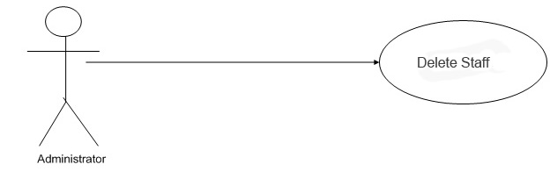

|  |  |
| --- | --- |
| Use Case Title | Delete Staff |
| Actors | Administrator |
| Pre-condition | Administrator must be entered into his account and has click on Delete Staff. |
| Trigger | Click on Delete . |
| Post-condition | Deleted successfully. |

**Activity Diagram Of Delete Staff:**



**3.2.9)Use Case of Add Finance:**

|  |  |
| --- | --- |
| Use Case ID | USECASE_ School Management system _13 |

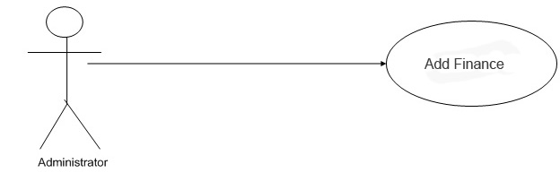

|  |  |
| --- | --- |
| Use Case Title | Add New Finance. |
| Actors | Administrator |
| Pre-condition | Administrator must be entered into his account and has click on Add Finance. |
| Trigger | Click on Add Finance. |
| Post-condition | Added successfully. |
| Main flow sequence | 1. Receiver Name. 2. Blood Group. |
| Alternative flow | If no data is entered in the field then error message will appear. |

**Activity Diagram of Add New Finance:**

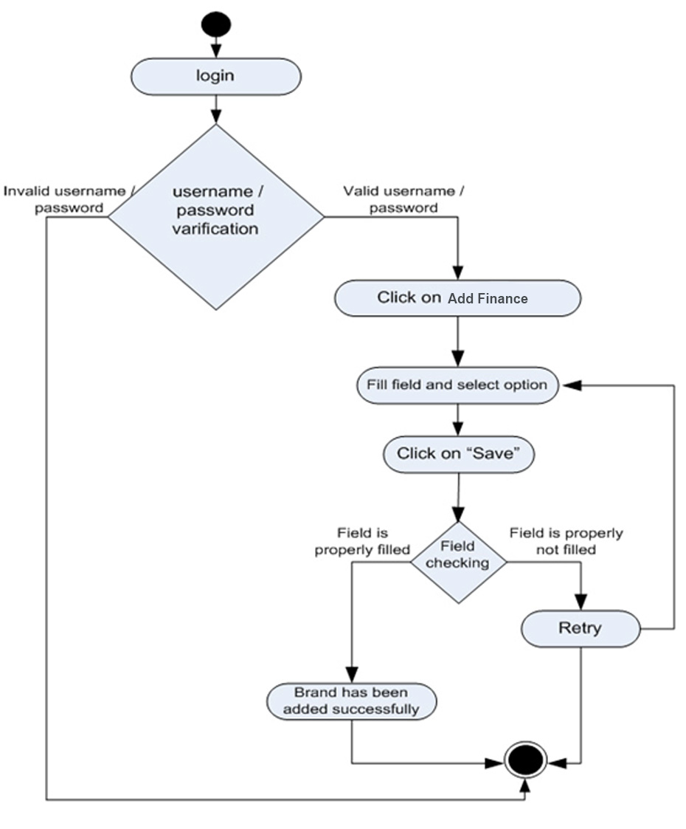

**3.2.7)Use Case of Update Finance:**

|  |  |
| --- | --- |
| Use Case ID | USECASE_ School Management system _7 |

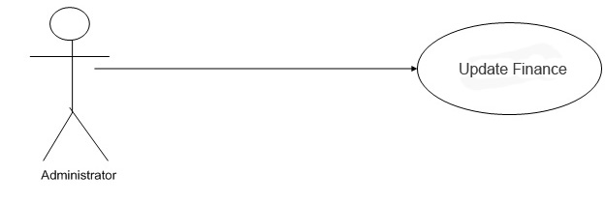

|  |  |
| --- | --- |
| Use Case Title | Update Finance |
| Actors | Administrator |
| Pre-condition | Administrator must be entered into his account and has click on Finance . |
| Trigger | Click on Update. |
| Post-condition | Update successfully. |

**Activity Diagram of Update Staff:**

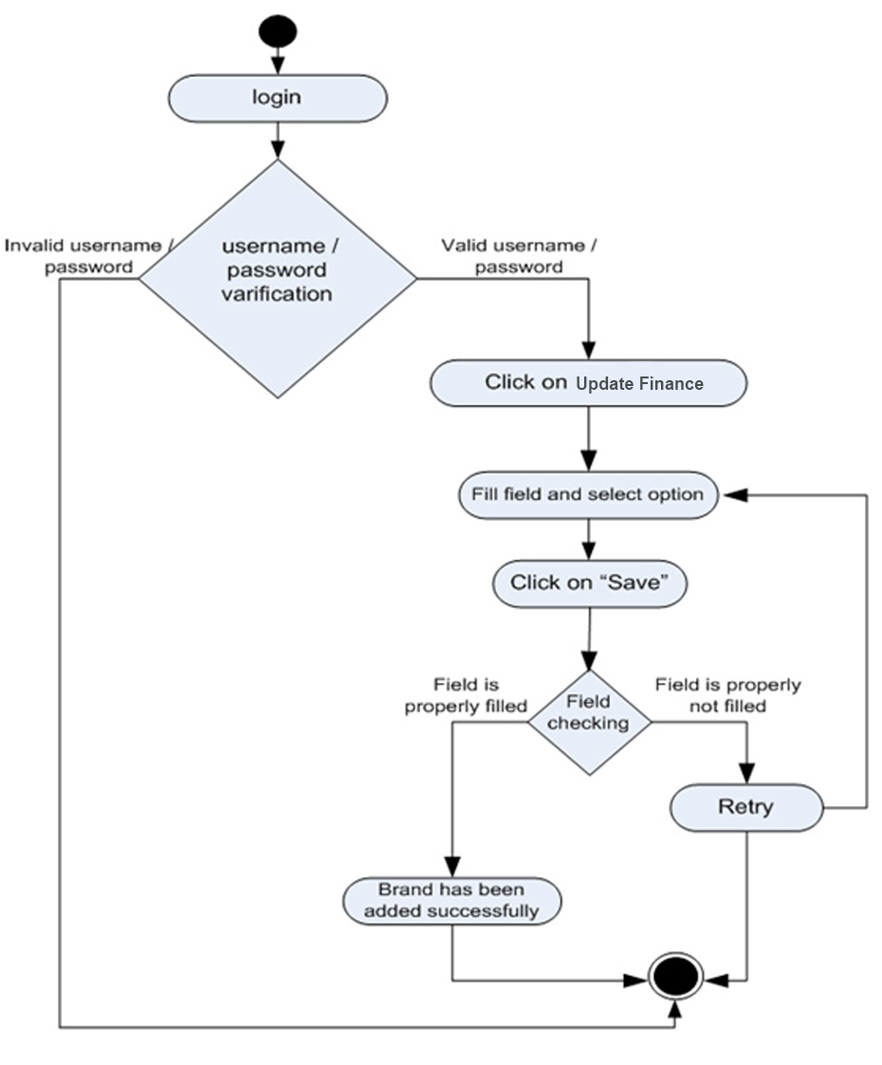

**Use Case of Delete Finance:**

|  |  |
| --- | --- |
| Use Case ID | USECASE_ School Management system _8 |

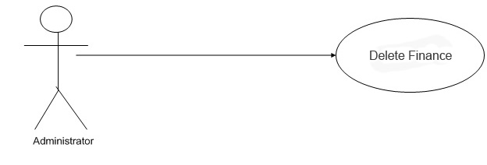

|  |  |
| --- | --- |
| Use Case Title | Delete Finance |
| Actors | Administrator |
| Pre-condition | Administrator must be entered into his account and has click on Delete Finance. |
| Trigger | Click on Delete . |
| Post-condition | Deleted successfully. |

**Activity Diagram Of Delete Finance:**



**Use Case of Login :**

|  |  |
| --- | --- |
| Use Case ID | USECASE_ School Management system _Login |



|  |  |
| --- | --- |
| Use Case Title | Login. |
| Actors | Administrator. |
| Pre-condition | For logging in Administrator must have a valid Username and Password. |
| Trigger | Enter the username , Password and click on the button. |
| Post-condition | Administrator enters correct username and password and he will login in into account and will be able to use the functionality, he can do. |
| Alternative flow | If wrong username and password entered in the login field then error message will appear. |

**Activity Diagram of Login**



**Use Case of Logout**

|  |  |
| --- | --- |
| Use Case ID | USECASE_ School Management system _Logout |



|  |  |
| --- | --- |
| Use Case Title | Logout. |
| Actors | Administrator. |
| Pre-condition | Administrator sign-out from his account. |
| Trigger | Click on the “Logout” button. |
| Post-condition | Administrator will logged out from his account. |

**Activity Diagram of Logout**



**Sequence Diagrams:**

**Main Panel Sequence Diagram:**

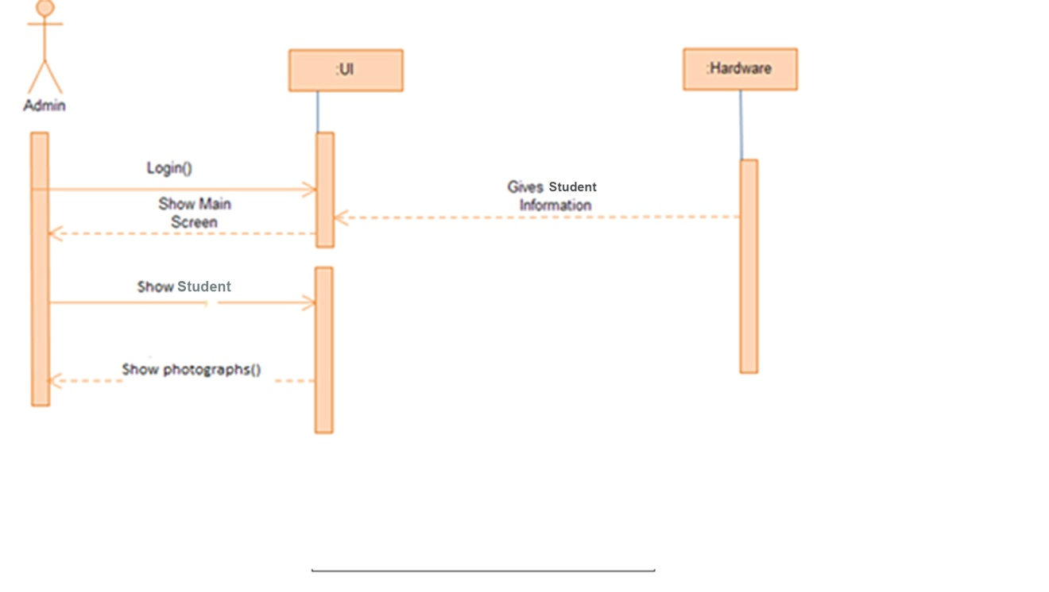

**User’s Sequence Diagram:**

**Getting Student Information Sequence Diagram:**

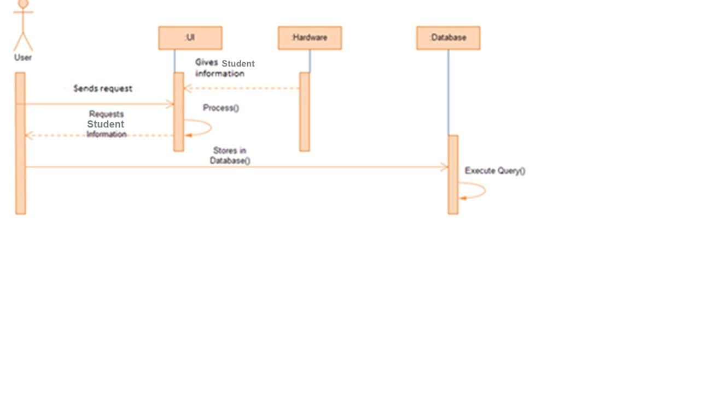

**Staff’s Sequence Diagram:**

**Staff’s Record Insertion Sequence Diagram:**

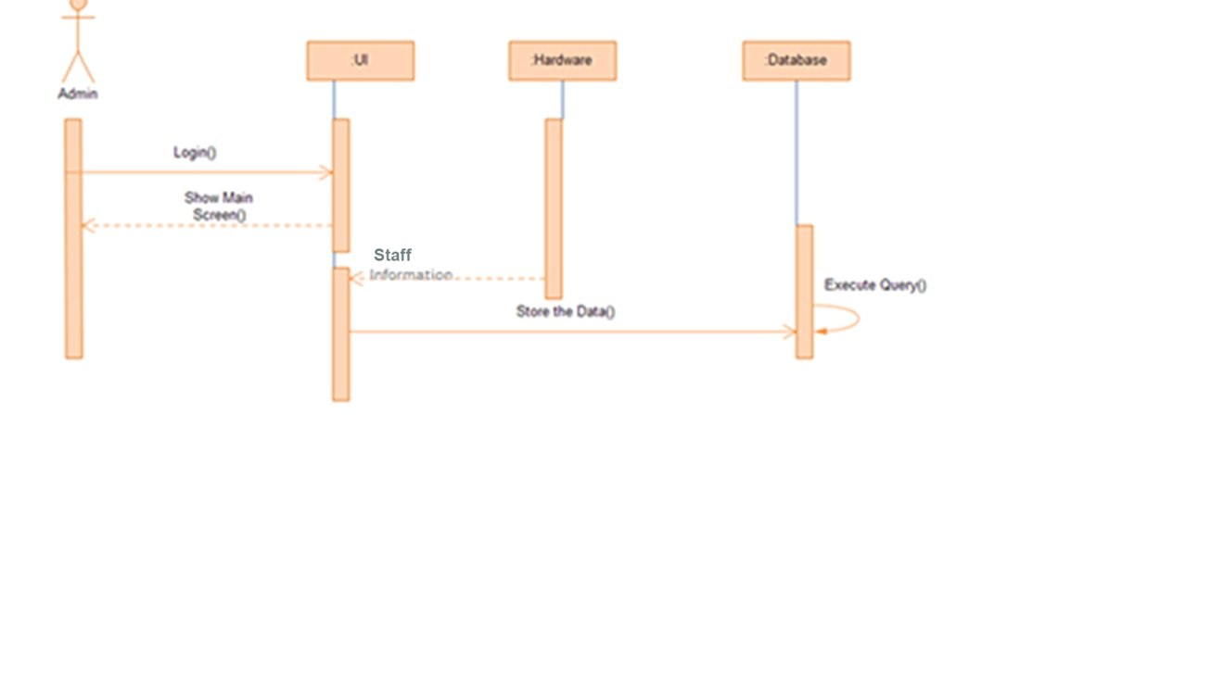

**Add New Record Sequence Diagram:**

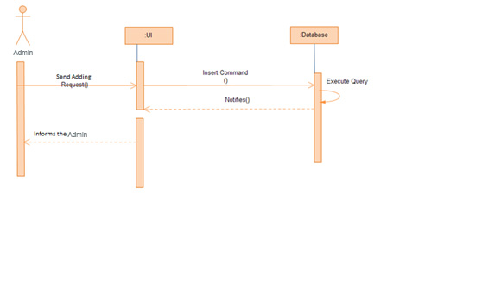**Remove Record Sequence Diagram:**

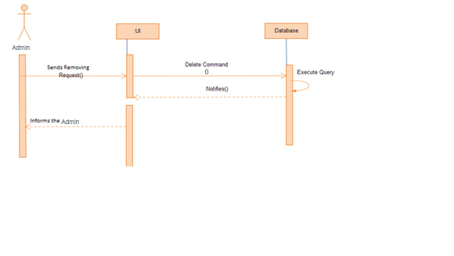

**Chapter: 05**

**System Design**

Design start with the analysis model as the major input. The principle activity to the

design is to reﬁne the analysis model such that it can be implemented with the components of architecture. Basic design activities inciude,

* Architectural Design
* Application Design
* Interface Design
* Database Design

**Architectural Design**

Architectural designs for web based systems and applications focuses on the deﬁnition of

overall hypermedia structure of the AppServ and the application of design patterns and

constructive templates to populate the structure. Basically a web application extends a website by enabling its user to invoke business logic and subsequently to change the state the business on the server. Web application is a client server software system that has , at a minimum the following architecturally signiﬁcant components :

1. An HTML browser on one or more clients communicating with a web server via
2. HTTP. An application server that manages business logic.

**Patterns**

Several architectural patterns exists. The two most common are as follows :

1. **Thin web client** used mostly for intemet based applications, in which there is little client configuration. The client requires only a standard forms capable web

browser. All of business logic is executed on the server.

1. **Thick web client** in this an architecturally signiﬁcant amount of business logic is executed on the client machines, Typically, the client uses dynamic HTML or AcitiveX controls to execute business logic. For the construction of system , I have the Thick Web client architecture patterns extends the Thin Web Client Patterns with the use of clint side scripting and custom objects, such as ActiveX com .In use of clint the business logic of the System.

**Structure**

Overall architecture structure is tied to the goals established for a Web application, the

Content to be presented, the user who will visit, and the navigation philosophy that has

been established, there four different structure for developing Website.

* **Linear Structure**

These Structure are encountered when a predictable sequence of interactions is common.

* **Grid Structure**

An architectural option that can be applied when the contents can be organized categorically in two dimensions.

* **Hierarchical Structure**

It is most common web application architecture. In such architecture ﬂow is across horizontal or vertical branches of system.

* **Network or “pure web” Structure**

The component designed following these structures may pass control to virtually every

other component in the system.

**Application Design**

The main objective of this design is to develop a modular program structure and represent

the control relationships between modules. It deﬁnes interfaces thus, enabling data to ﬂow throughout program.

* Partition objects into tires i.e client and server.
* Separating and deﬁning user interfaces or web pages.

The web application extension for UML has deﬁned notation to express the Web technology components of the system.

**Interface Design**

The interface of a system is often the measure by which the user of the system interacts

with it. If the system interface is very complex or presents information in a misleading

way , the user may confuse the meaning of information presented. They may initiate the

sequence of actions, which corrupt data or even cause catastrophic system allowing are some of the principles to be followed.

* **User Familiarity**

The interface should use terms, which are drawn from the experience of the anticipated

class or user. In many systems most of the things are memorable and recognizable.

* **Consistency**

The interface should be consistent in that comparable operations should be activated in

the same way. All the major functionality of our system activated through site.

* **User Guidance**

The interface should incorporate the same fomi of the context-sensitive user guidance

and assistance.

**Data Base Design**

* Database design the tasks performed are following.
* The data relationships between the data required by the user and represented.
* The data relationships between the suppose any transaction required on the data is provided.
* A design is speciﬁed that should achieved the requirement performance for the system.

**Data Base Table pics:-**

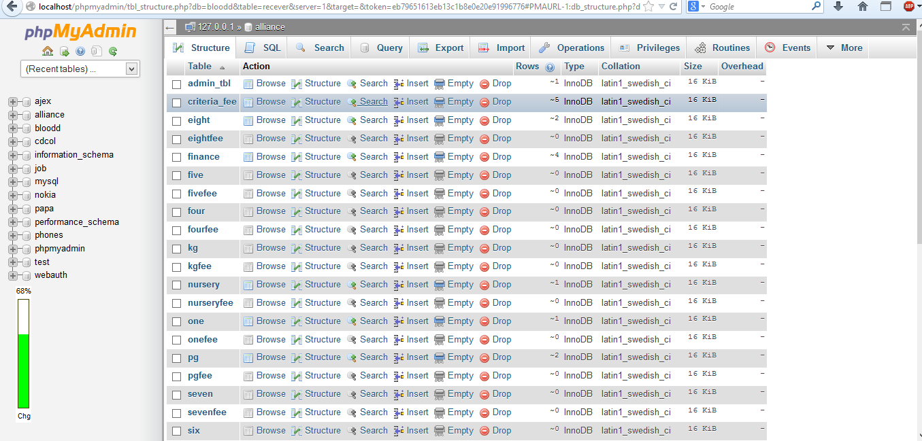

**1)Admin Table:**

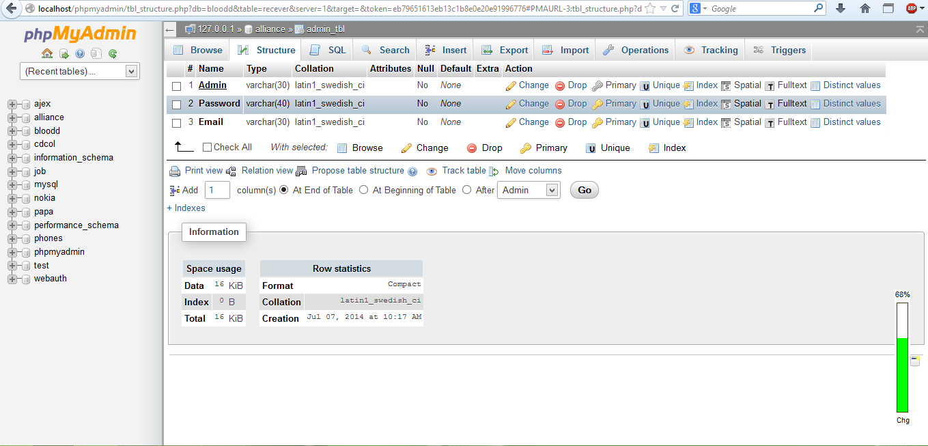

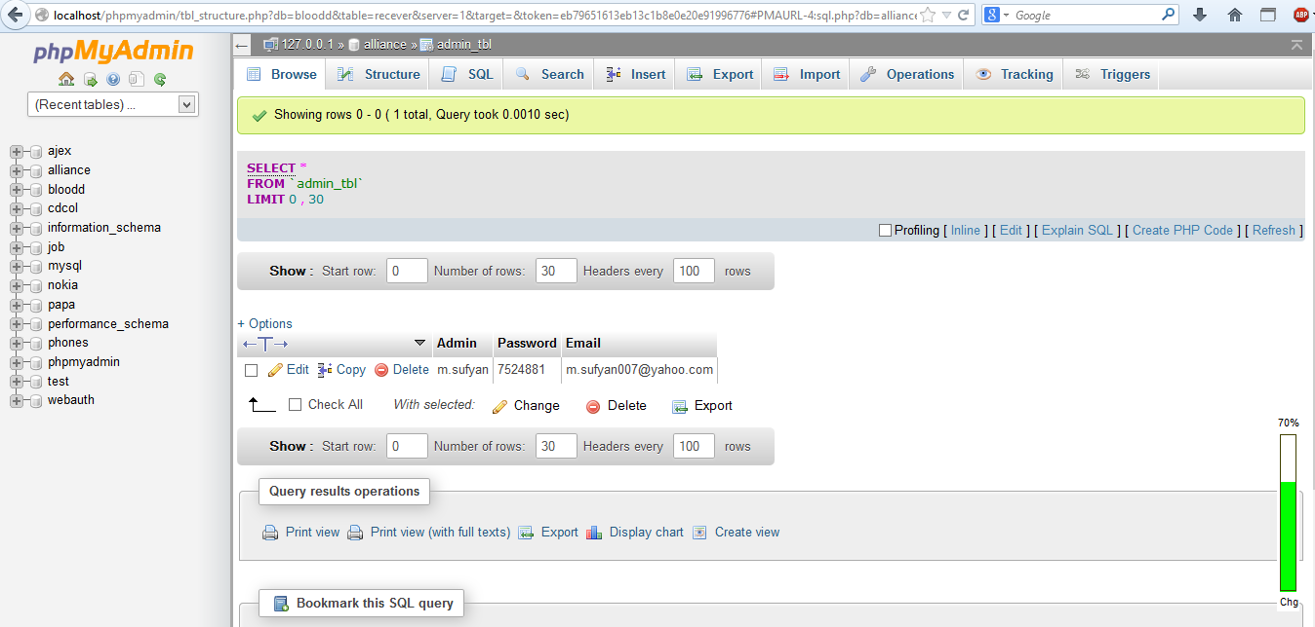

**2)Staff Table:**

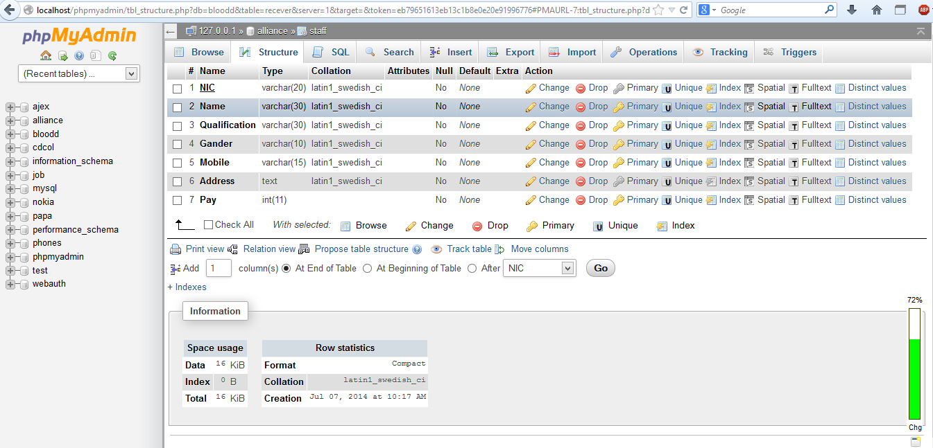

**3)Student Tables:**

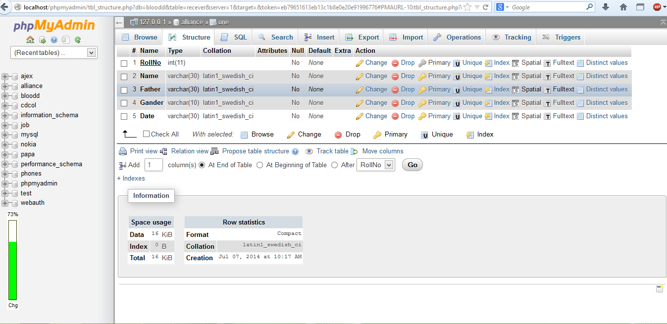

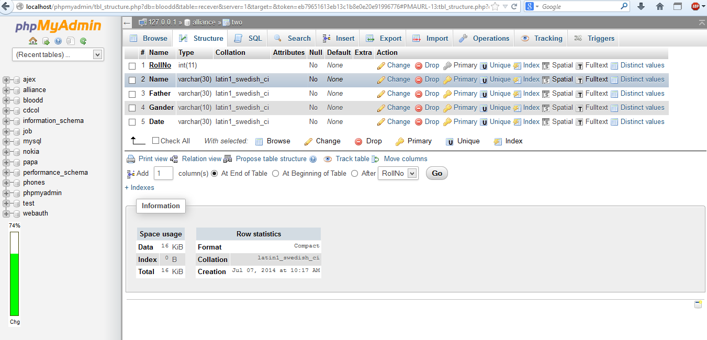

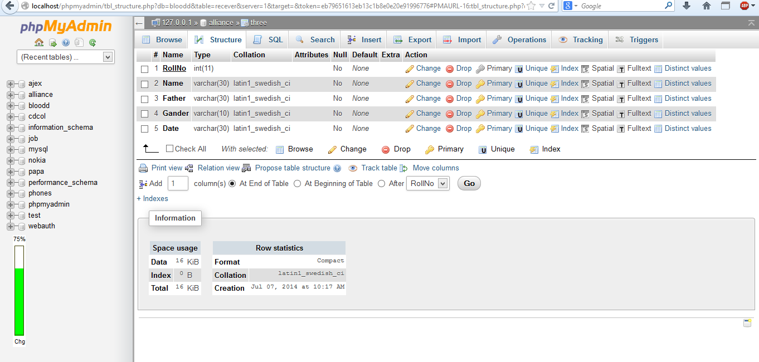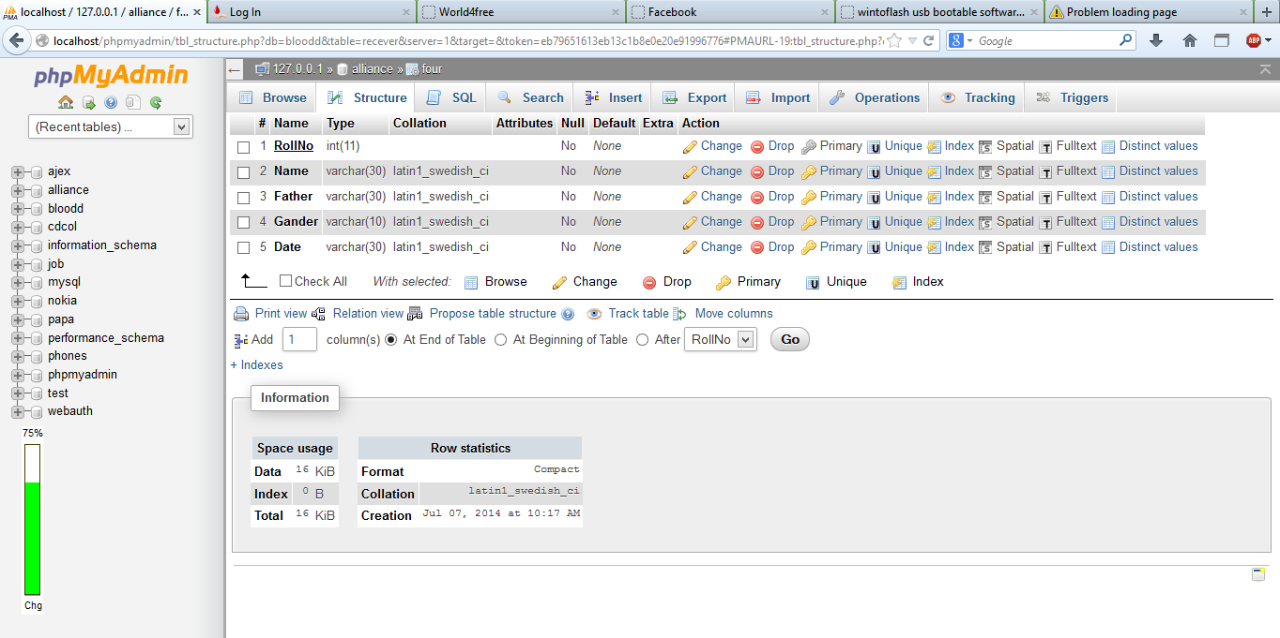

**4)Students Fee Table:**

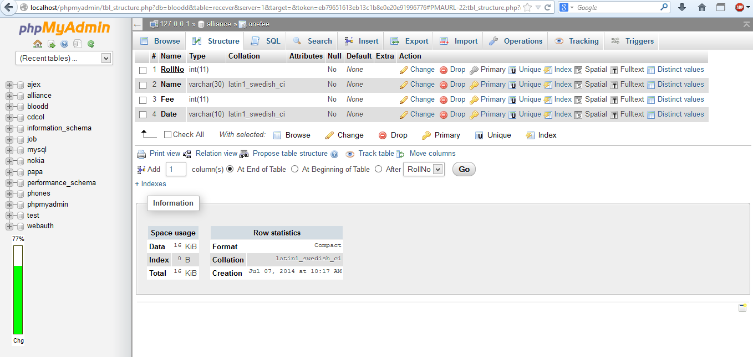

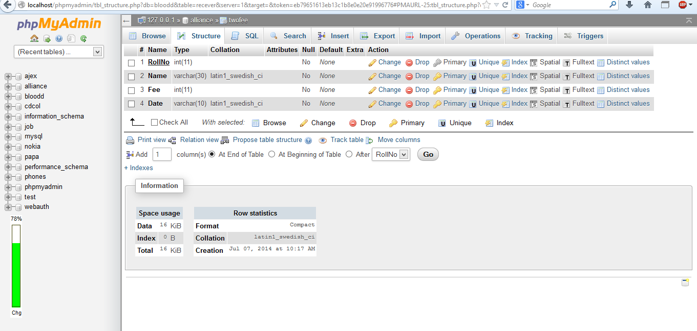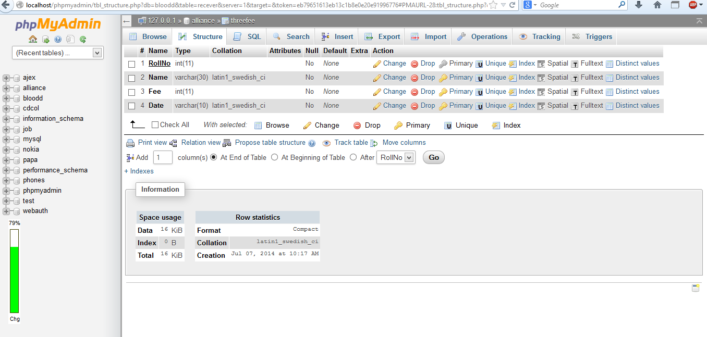

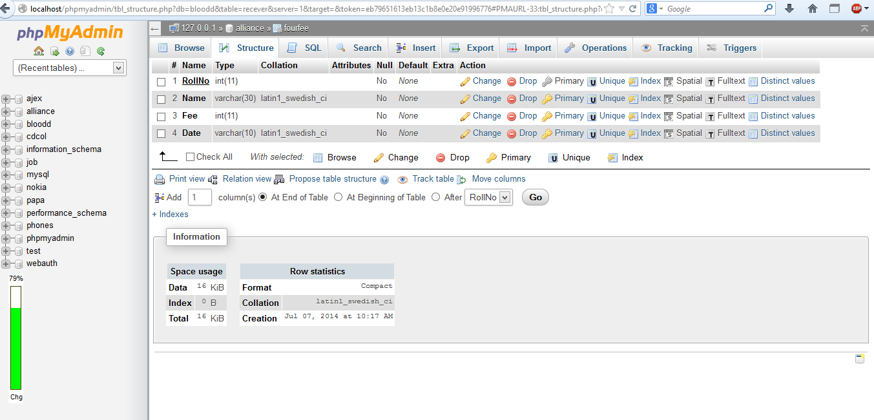

**Admission Criteria Table:**

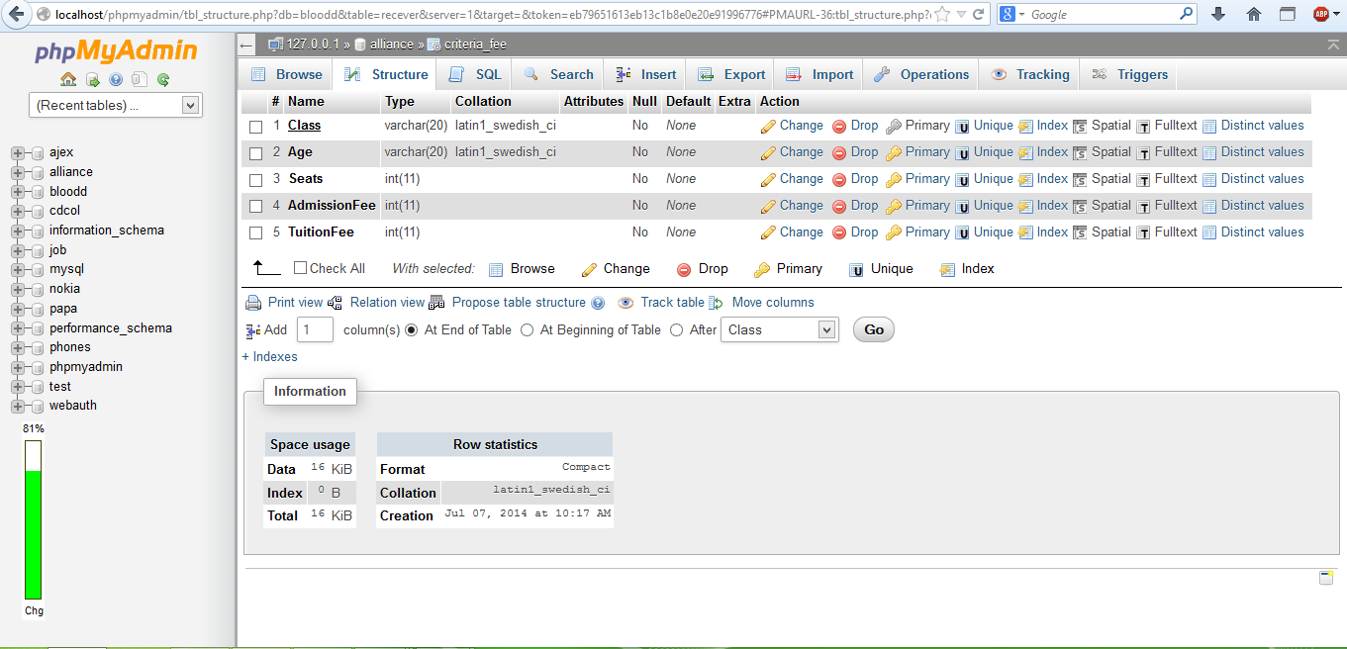

**Chapter: 05**

**Site Map**

**Site Map:**

AS the website is actor based so the site plan is according to the roles of the actors.

* Home
* Admission Criteria
* Schedule
* Staff
* Contact Us
* About Us
* SignIn

**Data Base Administrator:**

Forget Password

Admin change

SignIn

* Student
* View Students
* New Admission
* Fee
* View Fee
* Add Fee
* Add Criteria
* Staff
* Add new Staff
* View Staff
* Delete Staff
* Update Staff
* Finance
* Add new Finance
* View Finance
* Delete Finance
* Update Finance
* Action
* Delete Student
* Update Student
* Delete Fee
* Update Fee

Logout

**Chapter: 07**

**Screen Shots**

**Home Page:**

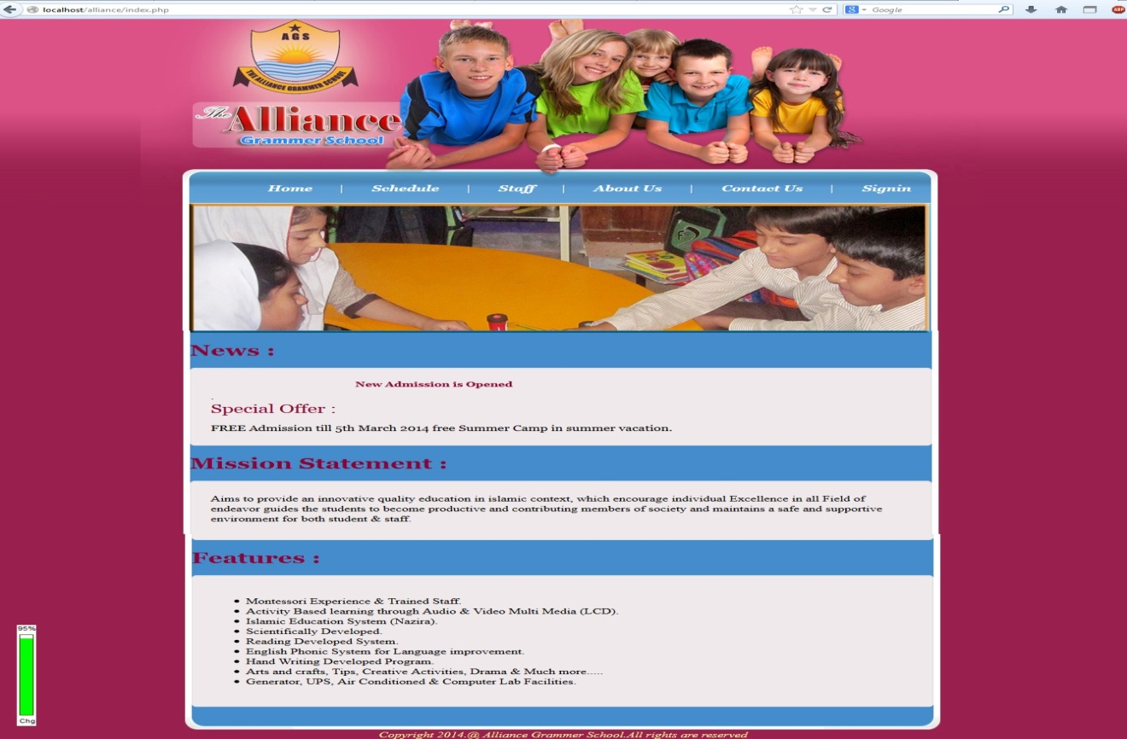

**Schedule page:**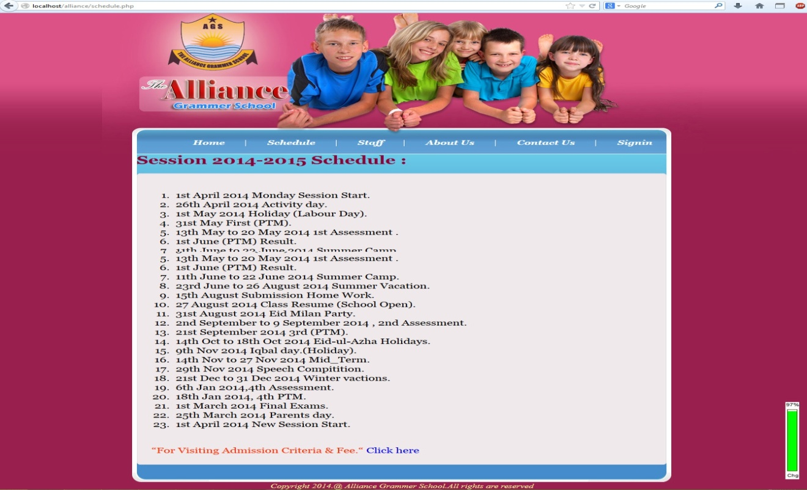

**Admission Criteria Page:**

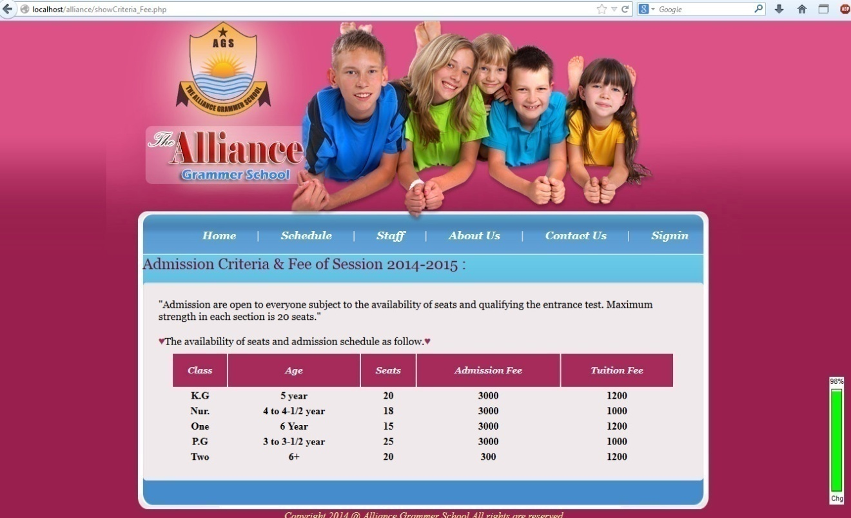

**Staff Page:**

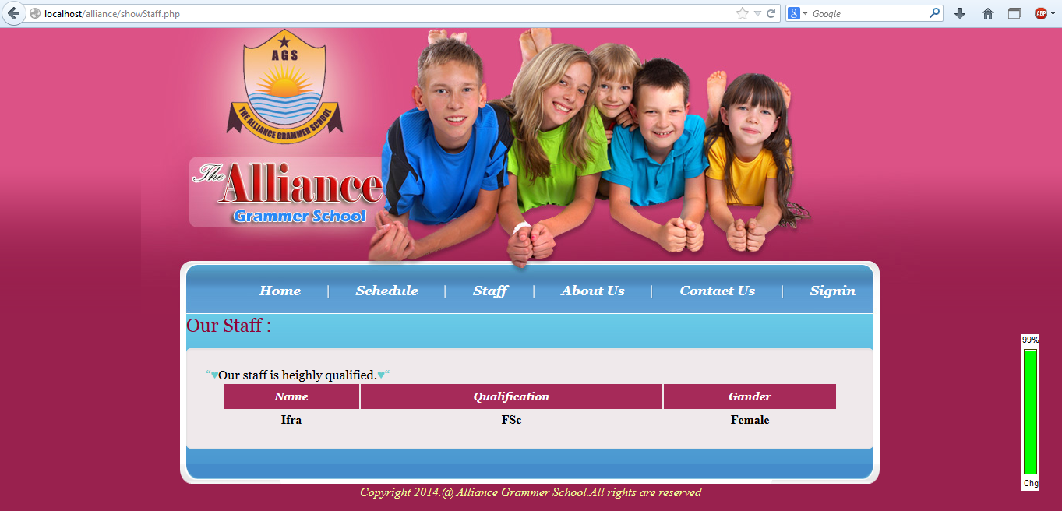

**About Us Page:**

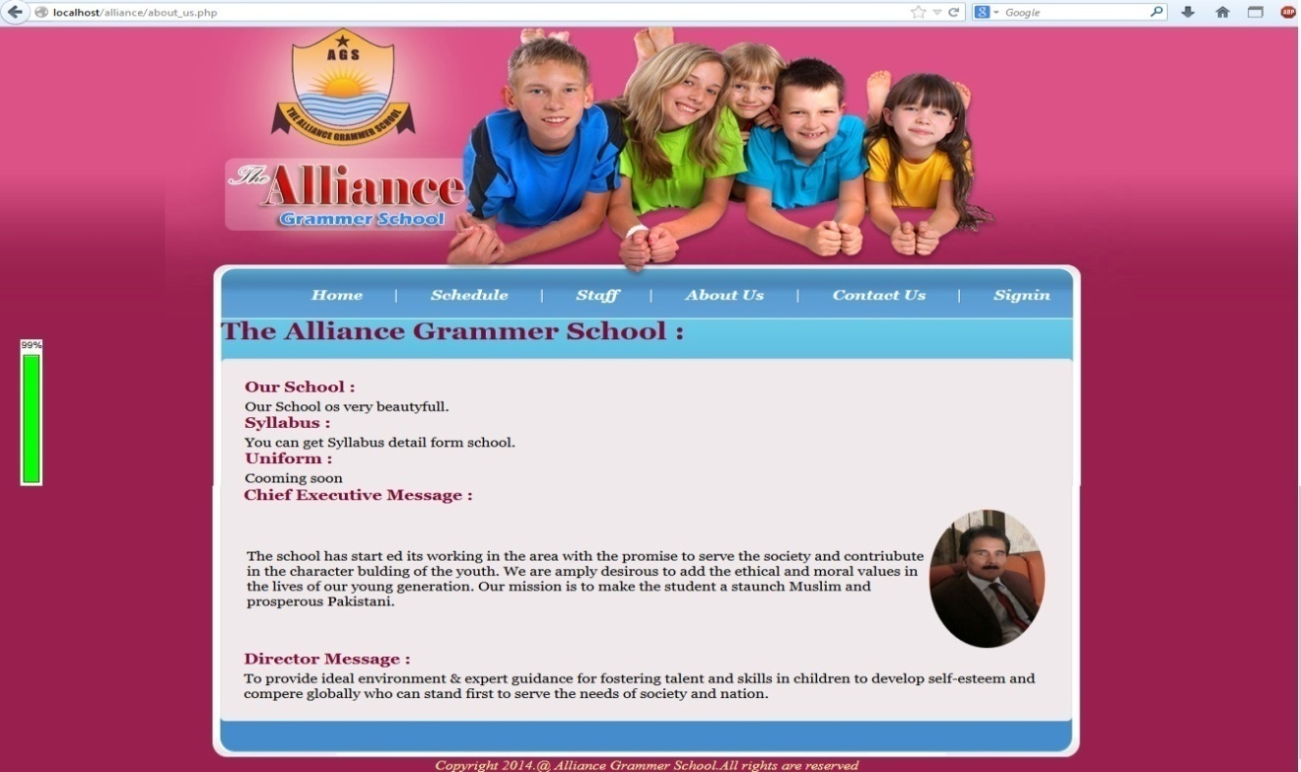

**Contact Us Page:**

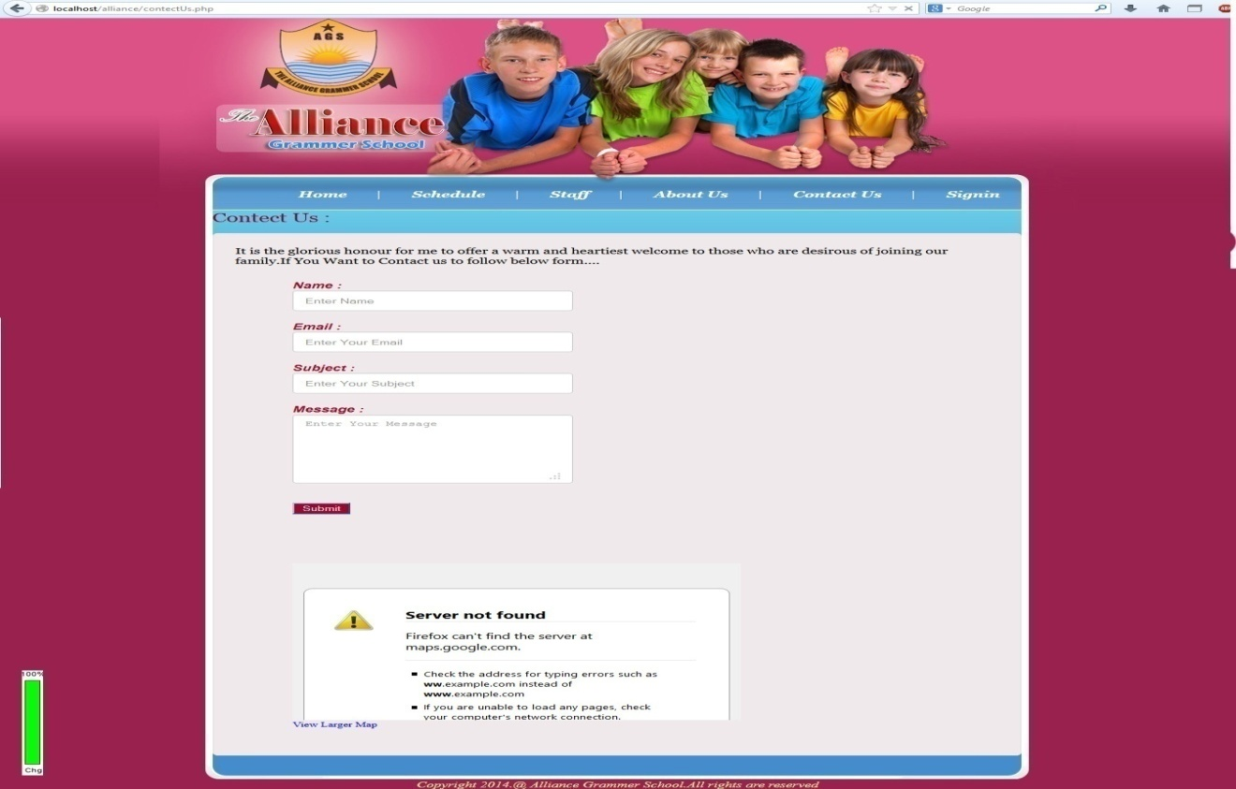

**Sign In Page:**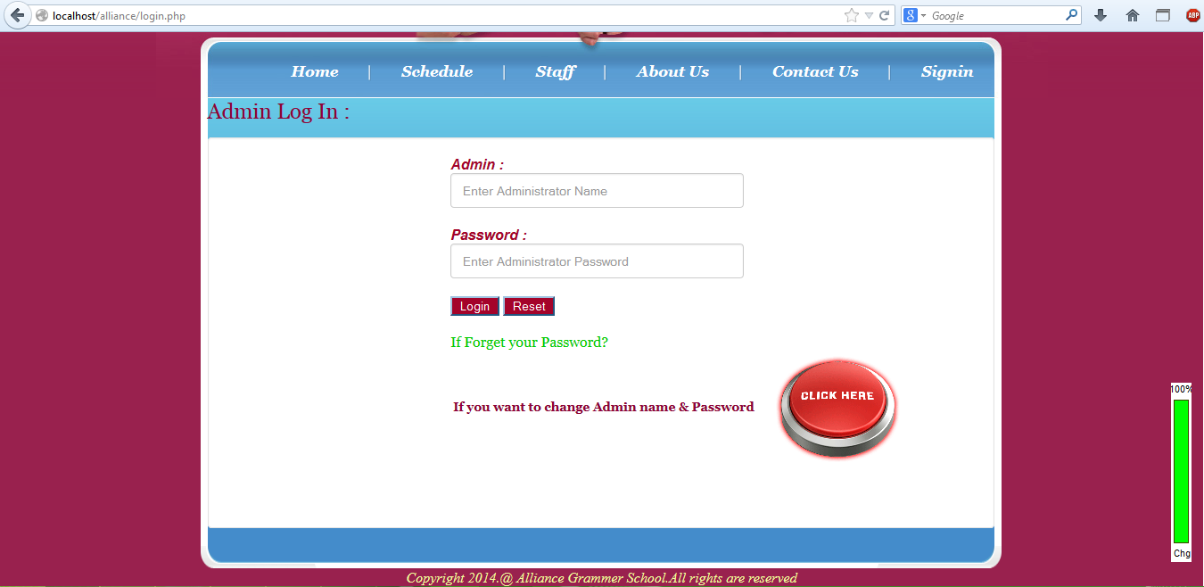

**Forget Password:**

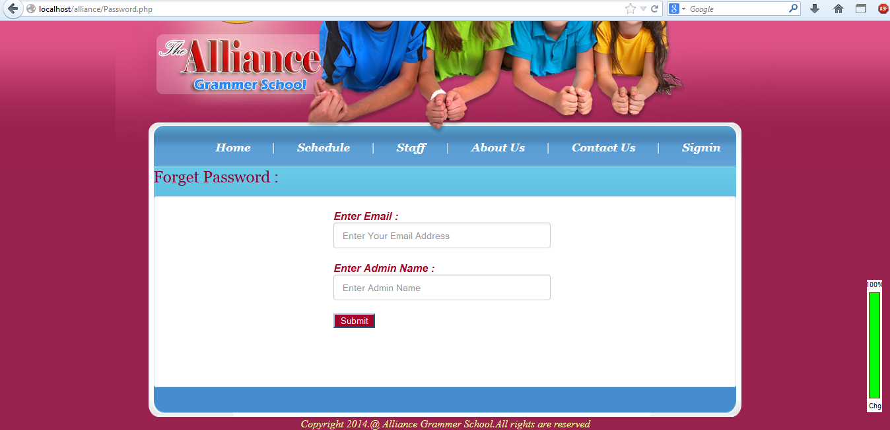

**Admin Change Page:**

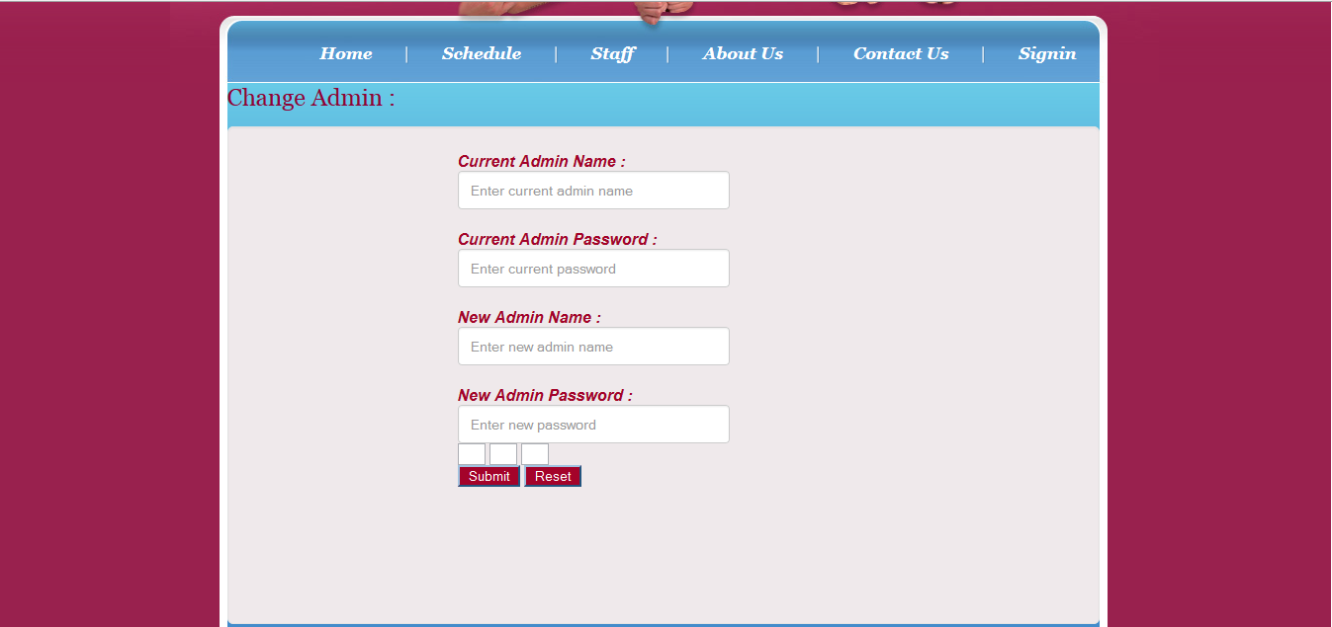

**Student View Page:**

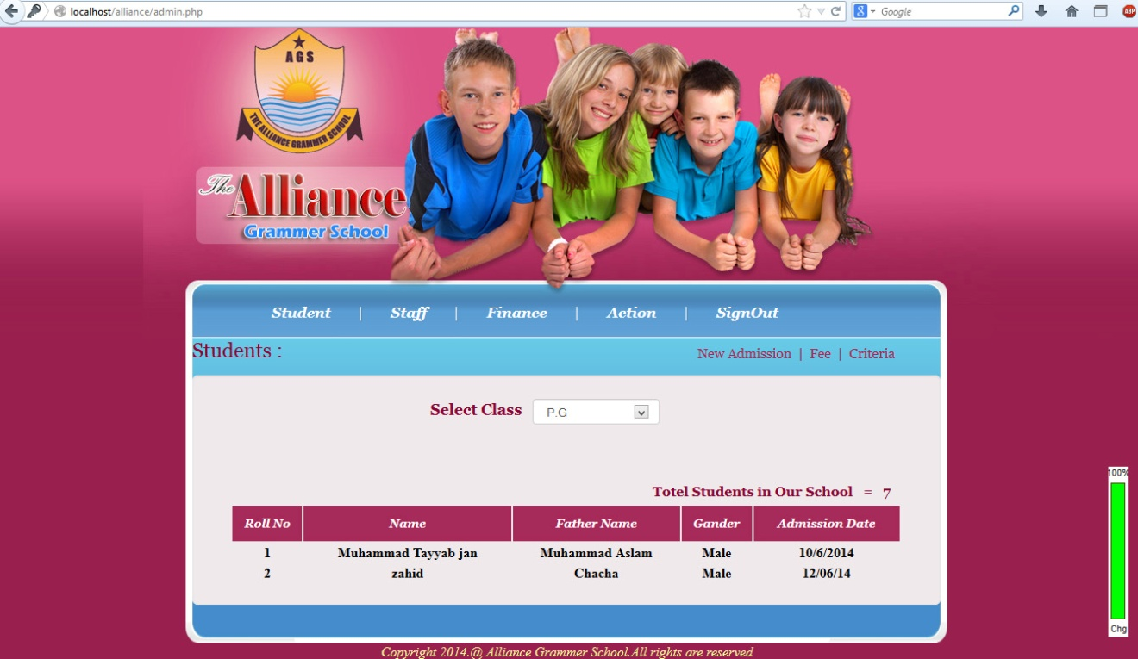

**Admission Page:**

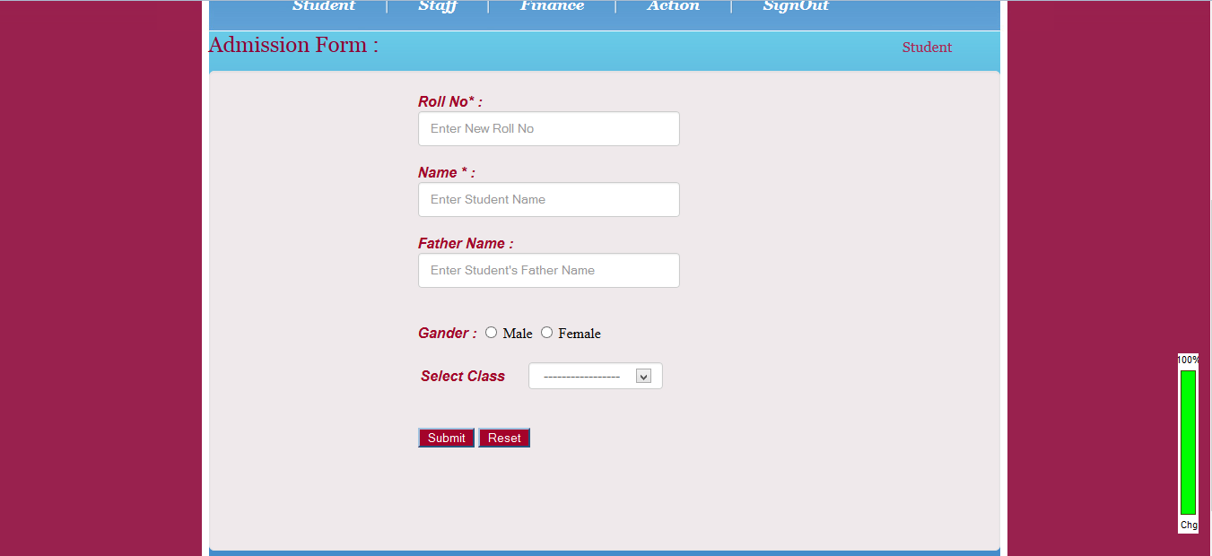

**Fee Page:**

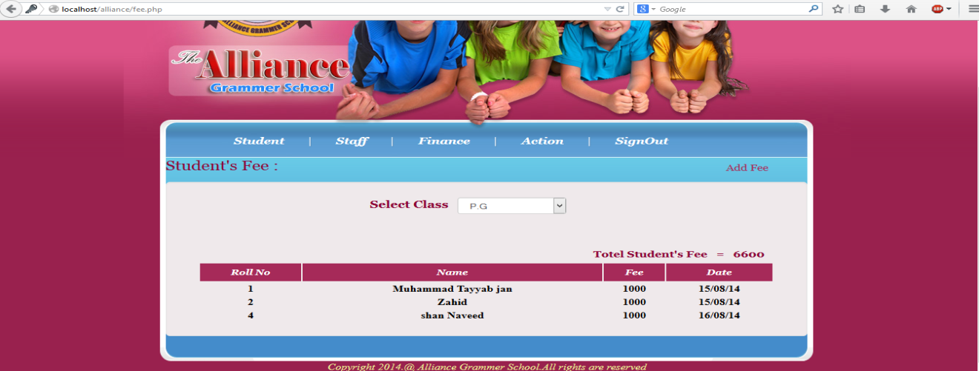

**Add Fee Page**

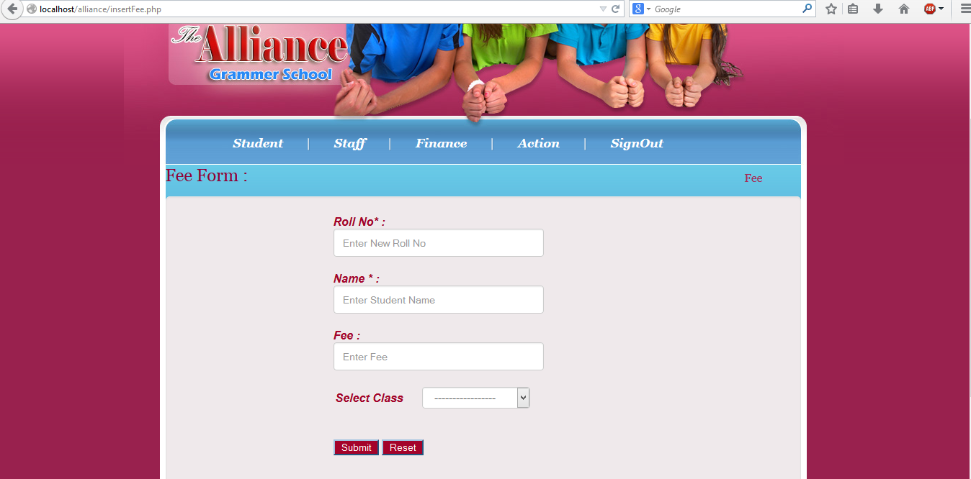

**Admin Staff Table:**

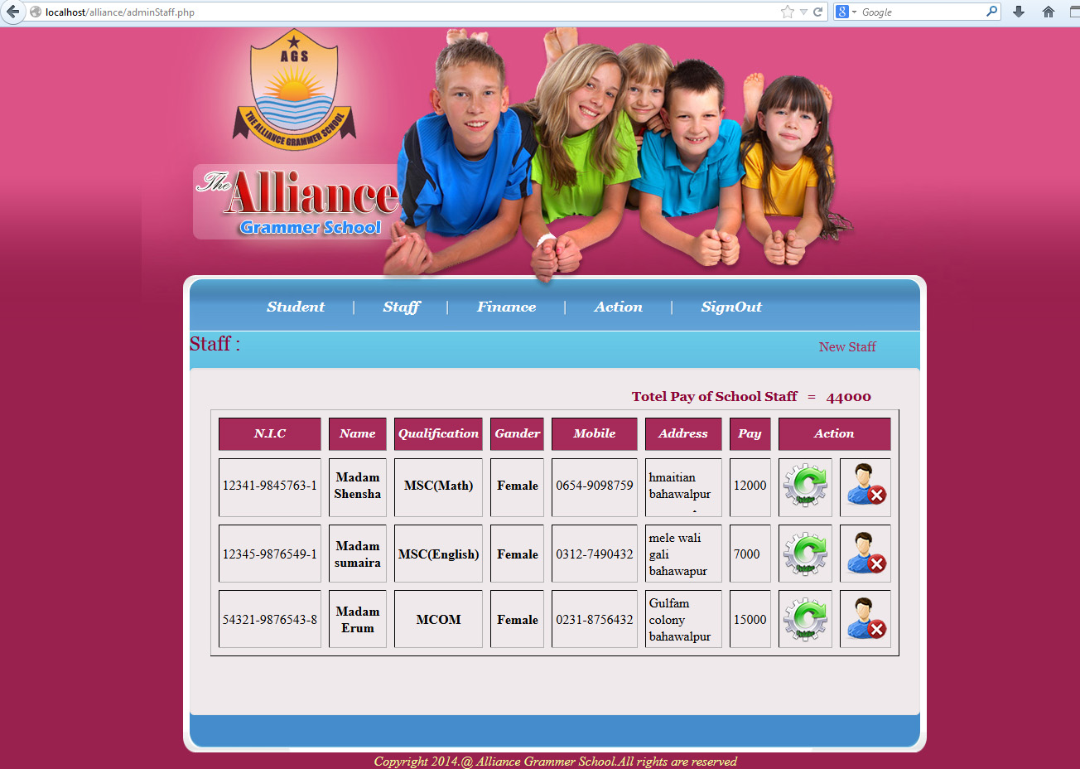

**Finance Table:**

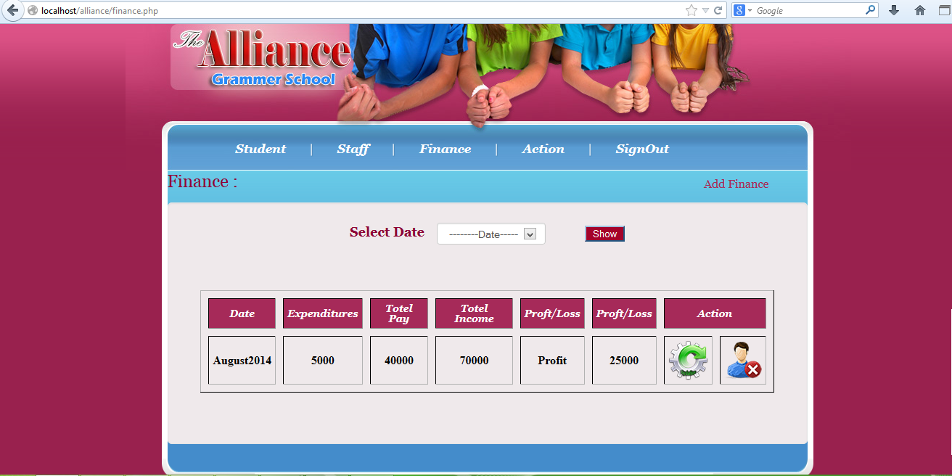

**Student Action Table:**

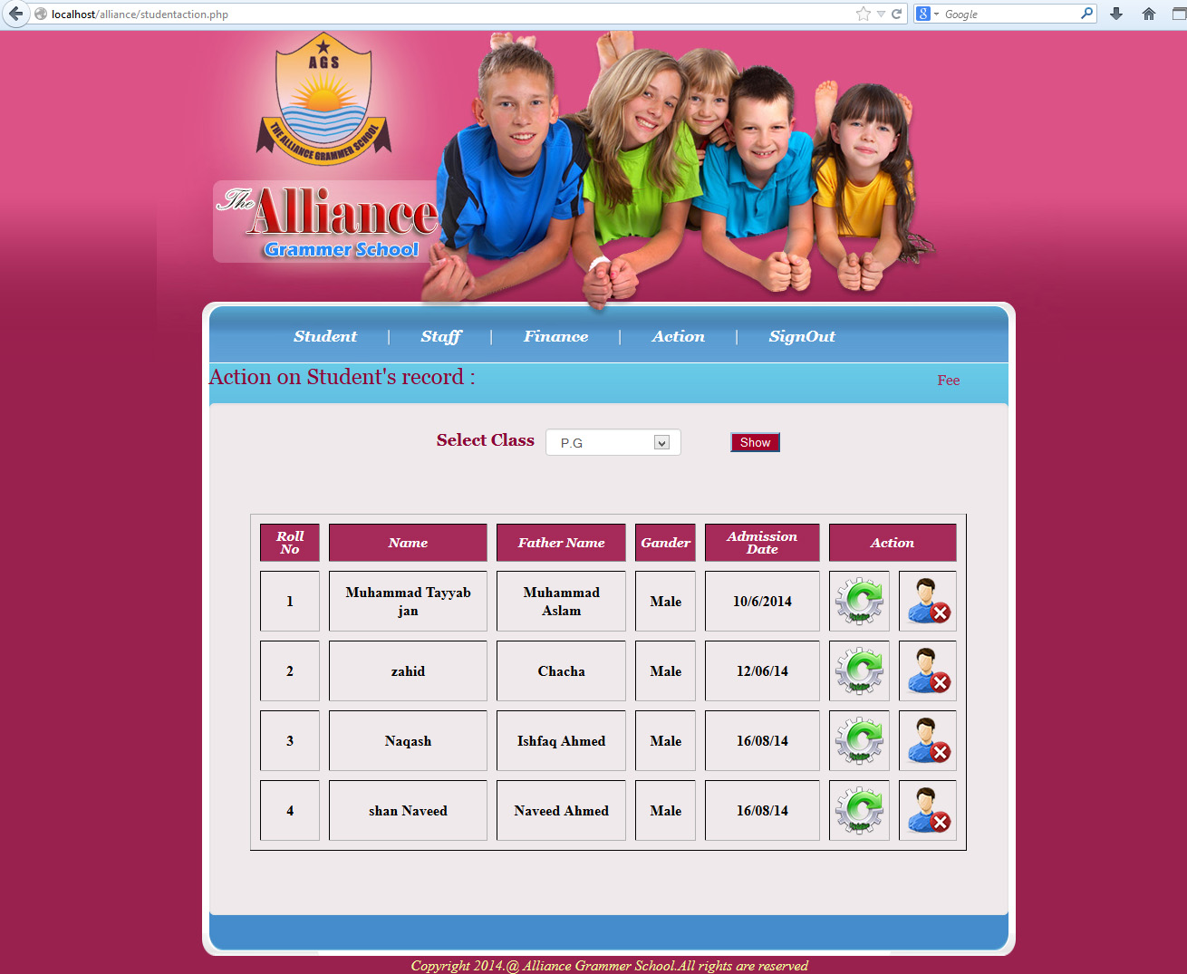

**Fee Action Table:**

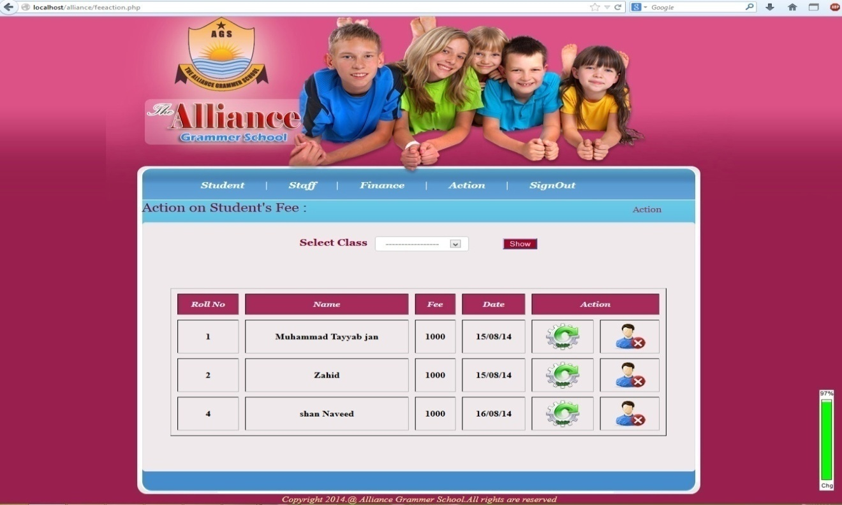

**Chapter: 08**

**Tool Used**

**8.1)Tool Selection:**

Once the system is proposed, the software design phase has been accomplished, the designer moves towards the development phase of software in accordance with the proposed system and design specification. Software development phase is an important phase. Special care is to taken while selecting software.

To develop the Advance Network Society successfully following tools and software were used. These professional software, tools and operating systems helped in a great deal to develop Advance Network Society. This chapter is all about the tools, software and the operating systems used in this project.

* PHP 5.3.5
* XAMPP
* MySQL
* Java Script
* Hyper Text Markup Language
* Cascading Style Sheet
* Adobe Dreamweaver CS6
* Adobe Photoshop CS5

**8.2) PHP**

PHP: Hypertext Preprocessor is a widely used, general-purpose scripting language that was originally designed for web development to produce dynamic web pages. For this purpose, PHP code is embedded into the HTML source document and interpreted by a web server with a PHP processor module, which generates the web page document. As a general-purpose programming language, PHP code is processed by an interpreter application in command-line mode performing desired operating system operations and producing program output on its standard output channel. It may also function as a graphical application. PHP is available as a processor for most modern web servers and as a standalone interpreter on most operating systems and computing platforms.

PHP was originally created by RasmusLerdorf in 1995 and has been in continuous development ever since. The main implementation of PHP is now produced by the PHP Groupand serves as the de facto standard for PHP as there is no formal specification.PHP is free software released under the PHP License.

PHP is a general-purpose scripting language that is especially suited to server-side web development where PHP generally runs on a web server. Any PHP code in a requested file is executed by the PHP runtime, usually to create dynamic web page content. It can also be used for command-line scripting and client-side GUI applications. PHP can be deployed on most web servers, many operating systems and platforms, and can be used with many relational database management systems. It is available free of charge, and the PHP Group provides the complete source code for users to build, customize and extend for their own use.

**8.3)Xampp the beginning.**

Xampp is not support by Thai Government or Corporation but this program was inspire by PhanupongPanyadee (AppServ Foundation). Concept of AppServ it is Easy to install Apache, PHP, MySQL in 1 minute. Many people in this world have problem when Install Apache, PHP, MySQL because use long time to configure and some time can make dizzy. First time of distribution provide on October 9, 2001. Many people use AppServ and growing up everywhere in this world. Right now AppServ website provide in Thai and English language. For the future AppServwet site will provide every languages on world.  
**Xampp** is a full-featured of Apache, MySQL, PHP, phpMyAdmin. You can setup in 1 minite.  
 **Package of Xampp**  
   - Apache  
    - PHP  
    - MySQL  
    - phpMyAdmin  
    All packages download from Official Binary Release. AppServ objective just make easy to setup. We do not provide anything else more than Official Binary Release package. Becuase we think the Official Binary Release work better than compile by individual or third-party binary.  
AppServ have only special configuration when install, Apache configure httpd.conf, MySQL configure my.ini, PHP configure php.ini. AppServ can guaranty any package from AppServ can work stable like Official of Apache, PHP, MySQL Release.  
    Objective of AppServ Just Easy to install. You can setup web server, database server in 1 minute.For some question AppServ can be Real Production Web Server or Database Server. We can tell you Yes !! 100% can make AppServ to provide Production Server. But Windows OS is not good enough for heavy load on you web or database server.Windows OS architecture use more memory and CPU usage we recommend you to use **Linux/Unix OS**to service heavy load of work. Because Linux/Unix OS have more speed and use less memory and CPU usage. If you compare hit when use Windows OS and Linux/Unix OS you must be found a very difference speed. e.g. Windows can handle 1000 users per second but Linux/Unix OS can handle more than 1000 users per second and eat a little memory and cpu.

**8.4) MySQL**

MySQL also commonly called "My Sequel" is a relational database management system (RDBMS) that runs as a server providing multi-user access to a number of databases. It is named after developer [Michael Widenius](http://en.wikipedia.org/wiki/Michael_Widenius)' daughter, My. The SQL phrase stands for Structured Query Language.

The MySQL development project has made its source code available under the terms of the GNU General Public License, as well as under a variety of proprietary agreements. MySQL was owned and sponsored by a single for-profit firm, the Swedish company MySQL AB, now owned by Oracle Corporation.

Free-software-open source projects that require a full-featured database management system often use MySQL. For commercial use, several paid editions are available, and offer additional functionality. Applications which use MySQL databases include: [Joomla](http://en.wikipedia.org/wiki/Joomla), [WordPress](http://en.wikipedia.org/wiki/WordPress), [MyBB](http://en.wikipedia.org/w/index.php?title=MyBB&action=edit&redlink=1), [phpBB](http://en.wikipedia.org/wiki/PhpBB), Drupal and other software built on the LAMP software stack. MySQL is also used in many high-profile, large-scale World Wide Web products and Facebook.

**8.4.1)Why MySQL?**

The MySQL database has become the world's most popular open source database because of its high performance, high reliability and ease of use. It is also the database of choice for a new generation of applications built on the LAMP stack (Linux, Apache, MySQL, PHP / Perl / Python.) Many of the world's largest and fastest-growing organizations including Facebook, Google, Adobe, Alcatel Lucent and Zappos rely on MySQL to save time and money powering their high-volume Web sites, business-critical systems and packaged software.

MySQL runs on more than 20 platforms including Linux, Windows, Mac OS, Solaris, HP-UX, IBM AIX, giving you the kind of flexibility that puts you in control. Whether you're new to database technology or an experienced developer or DBA, MySQL offers a comprehensive range of database tools, support, training and consulting services to make you successful.

**8.5) Java Script**

JavaScript is an implementation of the ECMAScript language standard and is typically used to enable programmatic access to computational objects within a host environment. It can be characterized as a prototype-based object-oriented scripting language that is dynamic, weakly typed and has first-class functions. It is also considered a functional programming languagelike Scheme because it has closures and supports higher-order functions.

JavaScript is primarily used in the form of client-side JavaScript, implemented as part of a web browser in order to provide enhanced user interfaces and dynamic websites. However, its use in applications outside web pages is also significant.

JavaScript uses syntax influenced by that of C syntax, also JavaScript copies many Java programming language names and naming conventions; but the two languages are otherwise unrelated and have very different semantics. The key design principles within JavaScript are taken from the self and Scheme programming languages.

**8.6) Hyper Text Markup Language**

Hypertext Markup Language (HTML) is the predominant markup language for web pages. HTML elements are the basic building-blocks of webpages.

HTML is written in the form of HTML elements consisting of tags, enclosed in angle brackets like <html>, within the web page content. HTML tags normally come in pairs like <h1> and </h1>. The first tag in a pair is the start tag, the second tag is the end tag. In between these tags web designers can add text, tables, images, etc.

The purpose of a web browser is to read HTML documents and compose them into visible or audible web pages. The browser does not display the HTML tags, but uses the tags to interpret the content of the page.

HTML elements form the building blocks of all websites. HTML allows images and objects to be embedded and can be used to create interactive forms. It provides a means to create structured documents by denoting structural semantics for text such as headings, paragraphs, lists, links, quotes and other items. It can embed [scripts](http://en.wikipedia.org/wiki/Scripting_language) in languages such as JavaScript which affect the behavior of HTML webpages.

Web browsers can also refer to Cascading Style Sheets (CSS) to define the appearance and layout of text and other material. The W3C, maintainer of both the HTML and the CSS standards, encourages the use of CSS over explicitly presentational HTML markup.

**8.7) HTML Elements**

HTML documents are composed entirely of HTML elements that, in their most general form have three components: a pair of tags, a "start tag" and "end tag"; some attributes within the start tag; and finally, any textual and graphical content between the start and end tags, perhaps including other nested elements. The HTML element is everything between and including the start and end tags. Each tag is enclosed in angle brackets.

The general form of an HTML element is therefore: <tag attribute1="value1" attribute2="value2">content</tag>. Some HTML elements are defined as empty elements and take the form <tag attribute1="value1" attribute2="value2" >. Empty elements may enclose no content. The name of an HTML element is the name used in the tags. Note that the end tag's name is preceded by a slash character, "/", and that in empty elements the slash does not appear. If attributes are not mentioned, default values are used in each case.

**8.8) Cascading Style Sheets**

Cascading Style Sheets (CSS) is a style sheet language used to describe the presentation semantics (the look and formatting) of a document written in a markup language. It’s most common application is to style web pages written in HTML and XHTML, but the language can also be applied to any kind of XML document, including SVG and XUL.

CSS is designed primarily to enable the separation of document content (written in HTML or a similar markup language) from document presentation, including elements such as the layout, colors, and fonts. This separation can improve content accessibility, provide more flexibility and control in the specification of presentation characteristics, enable multiple pages to share formatting, and reduce complexity and repetition in the structural content (such as by allowing for table less web design). CSS can also allow the same markup page to be presented in different styles for different rendering methods, such as on-screen, in print, by voice (when read out by a speech-based browser or screen reader) and on Braille-based, tactile devices. While the author of a document typically links that document to a CSS style sheet, readers can use a different style sheet, perhaps one on their own computer, to override the one the author has specified.

**8.9) Adobe Dreamweaver CS6**

Adobe® Dreamweaver® CS6 software empowers designers and developers to build standards-based websites with confidence. Design visually or directly in code, develop pages with content management systems, and accurately test browser compatibility thanks to integration with Adobe Browser Lab, a new Adobe CS Live online service.* CS Live services are complimentary for a limited time.

Get a jump on creating standards-based web pages with updated CSS-based starter pages. Enable CSS Inspect in Live View and tweak your design visually to get just the right margin and padding.

Test your pages in Adobe Browser Lab on multiple browsers and operating systems. Compare browser views in solo, side by side, or onion-skinned atop one another for pixel-precise matching.

Import any FLV file directly into Dreamweaver and quickly integrate a player skin of your choosing. Simply set options such as display size, auto start, and looping, and then your video is ready for the web.

**8.10) Adobe Photoshop CS6**

Adobe Photoshop CS6 Extended software is the ultimate solution for advanced digital imaging, delivering all the editing and compositing capabilities of Photoshop CS6 plus breakthrough tools that let you create and edit 3D and motion-based content.

Keep pushing creative boundaries with world-class 2D and 3D design. Use powerful new selection, painting, and warping capabilities to create standout images.

Get just the right look for each client's site. Easily select intricate image elements for placing in layout. Create 3D artwork for logos and buttons.

Create and enhance 3D and motion-based content and prepare still images and text for all your projects. Work fast with cross-platform 64-bit support, and create stunning HDR images for video backdrops.

Design cutting-edge looks for interactive web content and experiences. Create 3D artwork, warped graphics, and realistic painting effects for all your projects.

**8.11) Windows 8.1**

Windows 8.1 is the latest release of Microsoft Windows, a series of operating systems produced by Microsoft for use on personal computers, including home and business desktops, laptops, netbooks, tablet PCs, and media center PCs. Windows 7 was released to manufacturing on July 22, 2009, and reached general retail availability on October 22, 2009, less than three years after the release of its predecessor, Windows Vista. Windows 7's server counterpart, Windows Server 2008 R2, was released at the same time.

Unlike Windows Vista, which introduced a large number of new features, Windows 7 was intended to be a more focused, incremental upgrade to the Windows line, with the goal of being compatible with applications and hardware with which Windows Vista was already compatible.

Presentations given by Microsoft in 2008 focused on multi-touch support, a redesigned Windows shell with a new taskbar, referred to as the Superbar, a home networking system called HomeGroup, and performance improvements. Some standard applications that have been included with prior releases of Microsoft Windows, including Windows Calendar, Windows Mail, Windows Movie Maker, and Windows Photo Gallery, are not included in Windows 7.Most are instead offered separately at no charge as part of the Windows Live Essentials suite.

Windows 7 is available in six different editions, but only Home Premium, Professional, and Ultimate are widely available at retail. The other editions focus on other markets, such as the developing world or enterprise use. All editions support IA-32 CPUs and all editions except Starter support the x64 CPUs.

**REFERENCES**

Here Links of the references are provided which are been used in the development of this document:

[1] ( <http://searchsecurity.techtarget.com/definition/MD5>)

### [2] Research challenges claims of MD5 stability.

Refrence By [Sean Michael Kerner](http://www.esecurityplanet.com/author/4440/Sean-Michael-Kerner)  |  December 09, 2004

[3] http://en.wikipedia.org/wiki/MD5

[4] http://jcmc.indiana.edu/vol13/issue1/boyd.ellison.html

[5] http://www.ukoln.ac.uk/cultural-heritage/documents/briefing-13/briefing-13.doc

[6] <http://stakeholders.ofcom.org.uk/market-data-research/media>-literacy/archive/medlitpub/medlitpubrss/socialnetworking/summary/

[7] http://www.roseindia.net/struts/hibernate-spring/struts-login.shtml

[8]http://www.danah.org/papers/KnowledgeTree.pdf

[9] http://www.appsecinc.com/presentations/Manipulating SQL Server Using SQL Injection.pdf

[10] http://www.spidynamics.com/papers/SQLInjectionWhitePaper.pdf

[11] http://www.spidynamics.com/whitepapers/Blind SQLInjection.pdf

[12] [http://www.imperva.com/application defense center/white papers/](http://www.imperva.com/application%20defense%20center/white%20papers/)sql injection signatures evasion.html

[13] http://www.ngssoftware.com/research/papers/sqlinference.pdf

[14] <http://en.wikipedia.org/wiki/JQuery>